MID WEST DEER MANAGEMENT GROUP

MAY 2023 DRAFT

DEER MANAGEMENT PLAN
2023 – 2028
Background Information & Policies

PREFACE

This Deer Management Plan has been developed for the Mid West Deer Management Group (MW DMG). The Plan is funded by DMG members. It replaces a previous DMP drawn up in 2019, aiming to take account of changing circumstances within the group area. The Plan runs from 2023 until 2028 and has been formally endorsed by all the Members of the Group. It has been designed to be readily updated as needs arise and will be reviewed on a six-monthly basis or as required, with a systematic review taking place at the end of the five year period.

Group Secretary:
Victor Clements, Mamie’s Cottage, Taybridge Terrace, Aberfeldy, PH15 2BS
Tel (01887) 829 361 victor@nativewoods.co.uk

CONTENTS
Part One - Introduction
1. Purpose of Plan 3
2. Group Area 3
3. Group Membership 3
3a Member Description 4
3b Reporting Units 6
4. Deer Statistics Required 7
5. Designated Sites Introduction 7

Part Two - Overall Aims & Objectives
6. Long Term Vision 10
7. Strategic Objectives 10

Part Three - Management Policies & Information
8. Red Deer Population 12
Cull Information 18
Management Issues 33
Other Deer Species 36
9. Moorland Management 37
10. Sheep & Cattle 37
11. Forestry/ Woodlands 37
12. Supplementary Deer Policies 37
13. Non- Native deer species 39
14. Communications Policy & Contact 39
15. Training Policy 40
16. Review of Plan 41

Part Four - Operation of the Group
Assessment 42

Part Five - Public Interest Actions
Assessment 47

Part One - INTRODUCTION
1. Purpose of Plan
The purpose of this Plan is to provide:-
(a) an agreed statement of the shared views of the Members of the Group about the management of wild deer in the area covered by the Group;
(b) an agreed set of the actions to try and ensure that deer management in the area is in line with those shared views;
(c) an agreed set of actions that will identify and deliver relevant public interest and benefits throughout the area;
(d) an agreed pattern of arrangements to try and ensure that the actions are implemented and their effectiveness monitored;
(e) a document that acts as a ready source of information for both members and the general public alike, clarifying points of contact, and setting out how communications can best be received and addressed.

Maps and other documents referred to in this document can be located at: https://midwestassociationdmg.deer-management.co.uk/deer-management-plan/

2. Group Area
The Mid West Deer Management Group (MW DMG) area covers just over 106,000 ha (MW Location Map). It has seven active and subscribing members, and was formed in 1992. It is not part of any other local association, and operates under its own constitution (Appendix 11: Mid West DMG Constitution). The group subscribes to the Association of Deer Management Groups (ADMG). The boundaries of the area are:
- in the north: The A86 from Dalwhinnie through Spean Bridge to Fort William
- in the east: Loch Ericht from Dalwhinnie down to Bridge of Gaur
- in the South: From Bridge of Gaur running west broadly to the north of Rannoch Moor, and in a line along the Blackwater Resevoir to Kinlochleven and Loch Leven
- in the west: From Loch Leven up through the Mamores to Glen Nevis and on to Fort William.

A number of forested properties fenced off from the main deer range in the north east corner of the general area are not MW DMG members, likewise a number of properties between Glen Nevis and Loch Linnhe. Otherwise, the MWA covers 95% or more of the total land areas within its overall boundaries.

- Group Membership
MW DMG enjoys a very strong level of participation from among the seven members of the group (MW Members map). The John Muir Trust (JMT) are no longer members, but they report essential information to the group. There are four main management regimes within the group area, set out in the MW Management Objectives map:

- Nine management units covering 39,602 ha or 37% of the area whose priority is deer, but with other mixed conservation and land use objectives
- Two management units covering 32,321 ha or 30% of the area where the priority is water catchment management, but where deer and localized livestock are also important
- Five management units covering 22,226 ha or 21% of the area where the management priority is conservation management. This includes the John Muir Trust for whom access management is also a priority consideration.
- Eight management Units covering 12,009 ha or 11% of the area where forestry is the priority land use consideration.

Table 1 MW DMG Members & Principal Management Objectives

Property Main Objectives Size (ha)
Ardverikie Deer/ mixed objectives 14,932
Ben Alder Deer/ mixed 10,498
Camusericht Deer/ mixed 5121
Cruach Deer/ grouse/mixed 4620
Dunan Deer/ mixed conservation/sporting 3852
Forestry & Land Scotland Forestry 3902
Jahama Highland Estates Catchment management/ deer 32,326
John Muir Trust* Habitat restoration/ access 1800
The Corrour Trust Conservation management 23,447
Others Mixed c 5000 ha

Total area covered: 106,000 ha
*JMT are no longer a subscribing member of MW DMG but they report all essential information and are included in all DMG communications.

3a. Member Details
The following section gives a brief overview of the essential management information and contact details relating to each of the group members.

Ardverikie
Sitting to the south of Loch Laggan, Ardverikie is one of the larger members of the group. Low ground forestry interests are fenced off from the open hill, and there are no sheep on the hill area, leaving deer as the principal herbivore. Some opportunistic grouse shooting takes place if numbers justify this, but little in the way of extensive grouse moor management is undertaken. As with other DMG members, Ardverikie are currently looking at a number of conservation initiatives, including woodland creation and peatland management.

Ben Alder Estate

Located along the western shore of Loch Ericht, Ben Alder is a mixed estate with a strong conservation ethos. Like Ardverikie there are no sheep, with Red Deer being the principal herbivore. There are substantial forestry interests, particularly along the side of Loch Ericht and at the Dalwhinnie end of the Estate. Felling is currently taking place ‘loch side’ and commercial plantations, comprising mainly Sitka Spruce, are being replaced with Scots Pine and native broadleaves to improve wildlife habitat. The estate is actively engaged in identifying opportunities for woodland creation and peatland restoration, although the options for the former are limited due to peat depth covering much of the ground.

Camusericht Estate

Located at the southern end of Ben Alder, Camusericht is also a mixed estate with a strong conservation ethos and where Red Deer are the principal herbivore. There is a commercial forestry operation and the policy is to replant felled Sitka Spruce compartments with Scots Pine and native broadleaves. Opportunities for woodland creation and peatland restoration are being investigated.

Cruach
Sitting just to the north of Rannoch Moor, Cruach is slightly different to the other MW DMG members in spending a great deal of time on burning and grouse moor management. There are no sheep on the ground, but limited numbers of cattle. Deer numbers culled have been falling away steeply in recent years, with the estate seemingly under pressure from the Corrour culls and those associated with the Kinlochleven woodland scheme to the west. Cruach have a significant woodland interest, with areas being developed and managed with a view to sheltering and retaining deer on the property.

Dunan
Dunan is a relatively small estate within the MW DMG area, situated at the west end of Loch Rannoch. Red deer management is the primary land use objective. There are no livestock on the ground. There have been very extensive woodland plantings in recent years, and other opportunities for planting and conservation schemes more widely are being pursued. Fishing is also a management consideration on the property.

Forestry & Land Scotland
FLS have significant holdings at Leanachan and in Glen Nevis, both of which are only partially deer-fenced, although Leanachan Forest is considered to be deer-secure next to Ben Nevis. A 3000 ha plantation at Corrour was sold to the Corrour Trust about 15 years ago.
Priorities for FLS are forest protection and access management. Timber yields are high in Lochaber, and there are obviously good processing facilities nearby.

Jahama Highland Estates
Jahama Highland Estates are easily the single largest member within the MW DMG area, managing the two extensive estates of Killiechonate and Mamore. The prime objective for the land ownership is to control the water catchment area for the production of power through hydro-electric schemes to support the production of aluminium at the Lochaber Smelter in Fort William. Traditional management has involved red deer and grouse with extensive hill sheep grazing. In recent decades, almost 12,000 sheep have left the two estates, although there is still a sheep flock on the eastern part of Killiechonate, and crofters keep a small number of sheep as well. These are the only sheep in the MW DMG area.

John MuirTrust
The John Muir Trust manage their property at Ben Nevis for habitat restoration and access. Much of the ground is difficult to access. Some of the better native woodland areas within Glen Nevis lie on JMT ground. There are no livestock present.

JMT are no longer members of MW DMG but they provide all essential information and are included in all DMG communications.

The Corrour Trust
At over 23,000 ha, Corrour is the second biggest property within the MW DMG area. A significant change in management emphasis in recent decades has led to a greater focus on habitat restoration across the estate, looking at the broad range of natural habitats from native woodland through to alpine heaths, blanket bogs and montane grasslands. This has initiated an intensive red deer population reduction over the past number of years, and the culling targets having been achieved, by and large, as planned. Corrour expend considerable resources on habitat monitoring and deer counting and have excellent larder facilities. An Environmental Management Committee oversee this management, which includes input from organizations such as JMT as well as estate management staff and other specialist advice. Corrour own and manage significant woodland plantation areas at Corrour and at Inverlair. At both locations, restructuring towards native woodland and ancient woodland restoration are the management priorities.

3b. Reporting Units (For most properties, these refer to entire estate as before)
Extensive discussions during the production Management Unit level. (Tables 2-3 & MWDMG Reporting Units Map.)

Table 2 : West Sub-area Deer Management Units (area figures are approximate)

Management Unit Extent (ha) Priority Deer Management

FLS Blar a Chairuinn 1567 Forestry FLS
Killiechonate 17,128 Deer/Woodlands JHE
JMT Ben Nevis 1802 Access/ habitat JMT
Mamore (main pt) 13,278 Woodlands/ deer JHE
Mamore South 1904 Woodlands/deer JHE
Inverlair Woods 705 Forestry Corrour
Total: 36,394 ha

In addition, the following areas are not considered to be part of the MW DMG, but it may be that knowledge of deer culls in these areas would help inform efforts to regenerate habitats on Ben Nevis.

Management Unit Extent (ha) Priority Deer Management

Private Forestry 1078 Forestry Tilhill?
FLS Callert 290 Forestry FLS
Misc 1291 Mixed Misc

Table 3 : East Sub-area Deer Management Units (area figures are approximate)

Management Unit Extent (ha) Priority Deer Management

Cruach 4620 Deer/ mixed Cruach
Ben Alder Hill 7442 Deer/ sporting Ben Alder
BA- Lochside & Woods 3065 Deer/ mixed Ben Alder
Camusericht 5423 Deer/ mixed Camusericht
Dunan 3852 Deer/ mixed Dunan
West Ardverikie 3795 Deer/ mixed Ardverikie
Main Ardverikie 9420 Deer/ mixed Ardverikie
Ardverikie- For 1716 Forestry Ardverikie
Corrour Forest 3025 Woodland Corrour
Fersit 7110 Conservation Corrour
Beinn a’ Bhreac 6073 Conser/ deer Corrour
Beinn Eibhinn 3666 Conser/ Deer Corrour
Old Corrour 3371 Conser/ deer Corrour
Total: 62,578 ha

4. Deer Management Statistics
There is good deer cull information within the MWDMG area since 1998/99, with 4 X helicopter deer counts having taken place in that period in 2006, 2011, 2017 & 2017.

The data on deer counts and culls supplied by Members to MWDMG has always been based on their overall land holdings. Members agree, however, that for the purposes of implementing this Plan they will report counts and culls and set cull targets at the Reporting Unit scale (see above). This will allow a better analysis of the information provided in and around those areas of differing management objectives.

Members will agree on the deer management records that will be kept by all Members for sharing with the Group, including count and cull data, and the format in which these sets of data will be presented. The agreed formats are included in Appendix 4, MWDMG Deer Cull Information.

Recommended cull record sheets are appended to this document.

All MWDMG members agree to make sufficient resources available to carry out the culling programme outlined in this plan.

All culling operations will be conducted in a low key manner, and priority always given to spreading activity throughout the normal seasons using existing resources.

- THE DESIGNATED SITES IN THE MID WEST DMG AREA

Within the MW DMG area there are six different types of designation. The sites relevant to this plan are discussed in detail in Appendix 1: Designated sites information.

Sites of Special Scientific Interest (SSSI)
Special Areas of Conservation (SAC)
Special Protection Areas (SPA)
National Scenic Area (NSA)
Ramsar Sites
National Parks

Sites of Special Scientific Interest (SSSI)
Sites of Special Scientific Interest (SSSI) represent the best of Scotland’s natural heritage. They are ‘special’ for their plants, animals or habitats, their rocks or landforms, or a combination of such natural features. Together, they form a network of the best examples of natural features throughout Scotland, and support a wider network across Great Britain and the European Union.
Scottish Natural Heritage/ Nature Scot (SNH/NS) chooses sites after detailed survey and evaluation against published scientific criteria. SSSIs can include freshwater, and sea water down to the mean low water mark of spring tides, as well as land. At 31 March 2008, there were 1,456 SSSI’s, covering a total area of 1,036,000 hectares or 12.9% of Scotland.
SNH/NS designates SSSIs to protect the best of our natural heritage by making sure that decision-makers, managers of land and their advisors, as well as the planning authorities and other public bodies, are aware of them when considering changes in land-use or other activities which might affect them.
The Nature Conservation (Scotland) Act 2004 provides the legislative framework around which all SSSI sites are administered.

Special Areas of Conservation (SAC)
Special Areas of Conservation (SACs) are areas designated under the European Directive commonly known as the ‘Habitats’ Directive. Together with Special Protection Areas, which are designated under the Wild Birds Directive for wild birds and their habitats, SACs form the Natura 2000 network of sites. Most SACs on land or freshwater in Scotland are also underpinned by notification as Sites of Special Scientific Interest (SSSIs). The additional SAC designation is recognition that some or all of the wildlife and habitats are particularly valued in a European context.

Special Protection Areas (SPA)
These areas can be designated where more than 2% of the total UK numbers of a particular bird species is located or heavily dependent on a particular geographic area.

Ramsar Site
Ramsar is the name of a town in Iran where the Convention on Wetlands of International Importance was adopted in 1971. The UK Government signed up to the Convention in 1976.
The mission of the Convention is "the conservation and wise use of all wetlands through local and national actions and international co-operation, as a contribution towards achieving sustainable development throughout the world".
Currently 164 countries have signed up as Contracting Parties to the Convention with 2083 wetland sites designated for inclusion in the Ramsar List of Wetlands of International Importance.
There are currently 51 Ramsar sites designated as internationally important wetlands in Scotland, covering a total area of about 313,000 hectares. All Ramsar sites in Scotland are also either Special Protection Areas (SPAs) or Special Areas of Conservation (SACs), and many are also SSSIs, although the boundaries of the different designations are not always exactly the same. It is not surprising that internationally important wetlands are also of European interest for a wide variety of waterbirds, bogs, lochs, coastal wetlands and other water-dependent habitats and species. Although there is no specific legal framework that safeguards Scottish Ramsar sites, they benefit from the measures required to protect and enhance the Natura sites and SSSIs which overlap them. Scottish Natural Heritage/ Nature Scot (SNH/NS) also includes Ramsar sites in its site condition monitoring programme.

National Scenic areas
National Scenic Areas are Scotland’s only national landscape designation. They are those areas of land considered of national significance on the basis of their outstanding scenic interest which must be conserved as part of the country’s natural heritage. They have been selected for their characteristic features of scenery comprising a mixture of richly diverse landscapes including prominent landforms, coastline, sea and freshwater lochs, rivers, woodlands and moorlands.

There are currently 40 X NSA’s in Scotland, covering a total land area of 1,020,500 ha and a marine area of 357,900 ha.

Finally, a very small part of both Ben Alder and Ardverikie estates lie within the Cairngorms National Park area.

The two designated sites that dominate the MWDMG area both have SSSI and SAC status, namely the Ben Nevis SSSI/ SAC and the Ben Alder & Aonoch Beag SSSI/ SAC. In addition, Ben Nevis is also within the Ben Nevis & Glen Coe National Scenic Area and Ben Alder & Aonach Beag is also designated above the 700 metre contour level for breeding dotterel as the Ben Alder SPA.

All other designated sites within the area are more peripheral to either the geographic extent of the DMG or the internal dynamics of deer management within it.

The SSSI & SAC designated sites can be seen on the MW SSSI & SAC Designated sites map.

The area covered by the National Scenic Area, as well as the wild land area classification and the national parks can be seen on MW Landscape Designations Map.

Other designations relevant to the area can be seen on the MW Other Designations map.

A full account of all these sites, their current status and what properties are involved is given in Appendix 1, MWMG Designated Sites Information. In addition, Appendix 6, Monitoring of Designated features, details the likely contribution of deer to these sites.

Commentary
There are 100 X designated features within or around the DMG area.

There are 56 X designated features relating directly to deer.

Of these:

24 features or 43% are in Favourable condition or are not threatened by deer

11 features or 20% are in recovering condition, and are subject to a plan of action that might reasonably lead to Favourable condition status in the short or medium term. Habitat Impact Assessments have been showing progress on these sites.

21 features or 37% are listed as being in Unfavourable condition, the majority of these being designated woodland features.

More specific information on these sites is given later in this document.

Administration
Nature Scot (NS, formerly Scottish Natural Heritage) are responsible for the administration of designated sites.

In the context of this plan, Sinclair.Coghill@nature.scot is the wildlife management officer with primary responsibility for all matters relating directly to management of deer, and Lorraine.Servant@nature.scot is responsible for site management.

Part Two - OVERALL AIMS & OBJECTIVES

6. Long Term Vision
Members support the long term vision for deer populations and their management as laid out in Scotland's Wild Deer – A National Approach. Members also fully support the Code of Practice on Deer Management, and all work is carried out in accordance with Best Practice Guidelines, which continue to evolve.
- Deer populations will be managed sustainably so that their management is fully integrated with all local land uses and land use objectives.
- Such management will ensure high standards of deer welfare and public safety, and play a constructive role in the long term stewardship of local habitats.
- Local deer management will continue to deliver and further develop its positive contributions to the rural economy. Deer management and wildlife management more generally within the Group will be seen as an attractive and worthwhile occupation associated with high standards of skills and employment practice.

7. Strategic Objectives
The main objectives for the Group’s deer management during the period of this Plan, are as follows, in all cases adhering to Best Practice Guidelines:-
- To safeguard and promote deer welfare within the MW DMG area
- To achieve an appropriate balance between deer and their habitat, and between deer and other land uses, to minimize damage to agricultural, forestry, sporting or natural heritage interests, and to provide a conflict management role where significant differences in management objectives arise.
- Within the constraint of (ii) and the necessary management culls associated with this, to fulfil the annual sporting and venison production objectives of individual Members. This currently amounts to some 400 stags and approx 1400 animals overall.
- To market such activity and produce to best advantage.
- Without prejudice to (ii), to maintain a stable herd over the period of this plan, 2023-28, to keep numbers in line with actual sporting aspirations, and to facilitate an overall grazing regime that will gradually improve the overall condition of the upland designated sites. It is anticipated that the target summer population should be some 7500 animals, and numbers will be maintained at this level, subject to ongoing reviews of group objectives and regular habitat condition monitoring. This is c 30% less than the current population (2021)
- To ensure such resources, training and monitoring capacity that is required are made available to achieve the above objectives.
- To establish a thorough and robust set of working arrangements whereby access provision can be managed within the group area, taking account of current guidelines and industry initiatives.
- To facilitate the implementation of any other deer-related management agreements within the group area, and to provide a mechanism for dealing with any disputes.
- Where appropriate, to provide site specific management advice or information.
- To ensure full participation from throughout the area in the deer management group.
- To maintain and improve local employment, be that specifically in deer management or wildlife management and agricultural activity more generally within the area.
- To ensure that an effective system of communication is in place for the internal purpose of members, for the wider community of the area and for external agencies and other interested parties. The Group will seek to be pro-active in all their communications.

Part Three - MANAGEMENT POLICIES & INFORMATION

8. Red Deer
Red Deer Population
The Mid West DMG would find it extremely difficult to carry out an accurate red deer foot count due to the difficult terrain, but has had four helicopter counts since 2006 (2006, 2011, 2017, 2021). In the first of these, hinds and calves where not distinguished from one another, but a better classification is available for the last 3 X counts.

The following four maps show how the broad deer distribution and density has changed over this period of 15 years or so.

In all these graphs, white denotes densities less than 2 deer per sq km, yellow is 2-5 deer per sq km, green is 6- 10 per sq km, purple is 11-14 deer per sq km, red is 15- 19 deer per sq km, and the very dark red/ purple colour is 20 + deer per sq km. Wooded areas are shown in dark green.

In 2006, below, deer densities to the west of the DMG area are generally low, less than 5 per sq km. Densities in the east are much higher, with all areas being more than 15 deer per sq km. There are no very high or very low densities. At this point, the difference in densities across the area are very pronounced, there was a large unfenced native woodland scheme at Kinlochleven, and another one being contemplated around Glen Nevis, although this never did materialize. This was driving management objectives at that time.

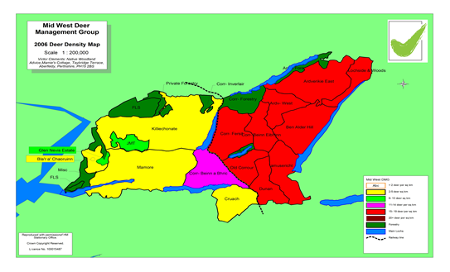

By 2011, the western densities had become higher, moving up to the next density band, and most of the properties in the east had reduced densities, with several areas falling in to the 11-14 deer per sq km banding. See map below. Part of the reason for this was changing objectives at Corrour, but other estates had wider conservation objectives as well.
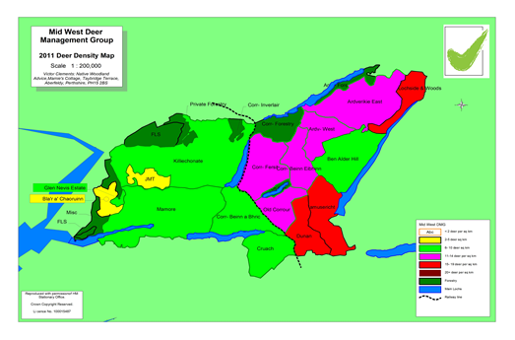
By 2017, below, the west area was still green, but densities where then towards the upper end of the 6-10 deer per sq km bracket. There is more of a diversity of densities in the east, with the very high densities appearing for the first time. At this point, the south part of Mamore was not counted, but it appears that the overall deer density there was as depicted.
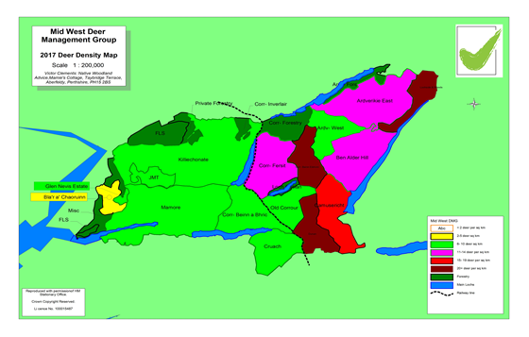

By 2021, below, Corrour had undertaken a very significant reduction cull, with densities on all their beats down to less than 2 deer per sq km (actually all less than 1 deer per sq km). Densities in the west were still increasing, with Mamore rising to the next higher band. In the east, there were marked reductions on a number of properties.
Several DMG members have suggested that the Corrour cull gave them higher counts than they were expecting, but there is no way of knowing whether this is right or not. There are now broadly 3 X deer density zones, with the west being much higher than 2006, the east being generally lower, and the middle zone with very few deer at all, although this may well have changed a bit again since 2021 as deer even themselves out again.

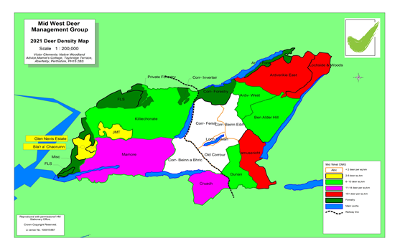

The above changes can be quantified in the graph below. The blue line shows that the deer population across the eastern side of the group has fallen by half from 2006- 2021, from 16 to 8 deer per sq km. The orange line shows the deer density to the west has increased by 2.5 times since 2006, from 4- 10 deer per sq km. Overall, DMG deer density has decreased by one third, from 12 to 8 deer per sq km.

Obviously, there is important detail within this.

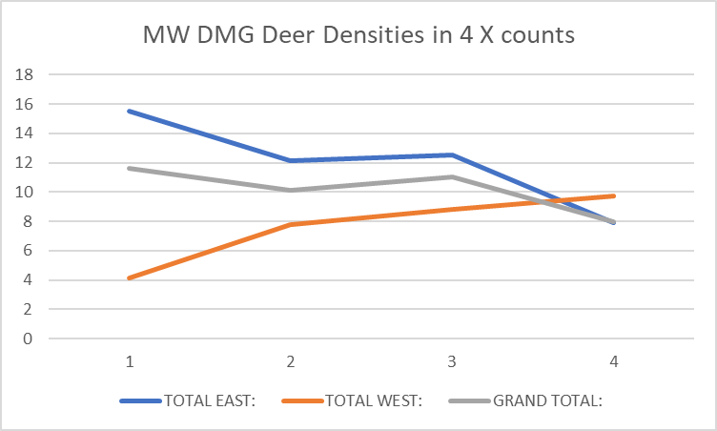

Ardverikie and Ben Alder are the two largest properties towards the east of the DMG, with Camusericht being a subsidiary estate within the overall Ben Alder ownership. The graph below shows that for Ardverikie and Ben Alder, densities have fallen from 15 to just above 10 in fifteen years, a fall of one third. Camusericht has always had a higher density throughout, and the decrease there in numbers has not been so obvious.

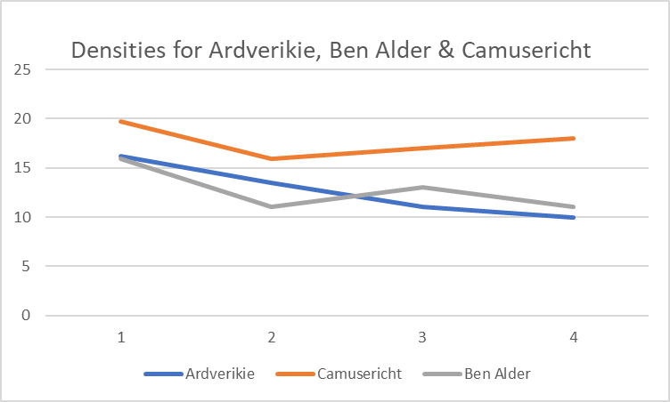

Dunan & Cruach are much smaller properties within the eastern side of the DMG, but at the southern end. The orange line below shows the Cruach deer density broadly increasing over the period, although this is largely because of a much reduced cull. The Dunan population remained quite high and rising through to 2017, but has fallen away very significantly since then.

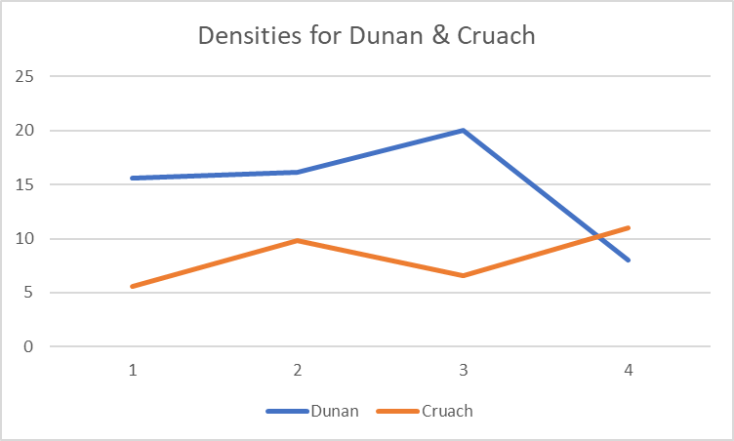

On Corrour, below, they have had conservation objectives throughout. There was a fall in deer density between 2006-11, but this stayed steady through to 2017, before falling away to less than 1 deer per sq km in 2021 after a number of very large culls, with the last big cull season in 2020-21. You can see in the graph below that the eastern density has always been much higher than the west, but they are both at low levels now.
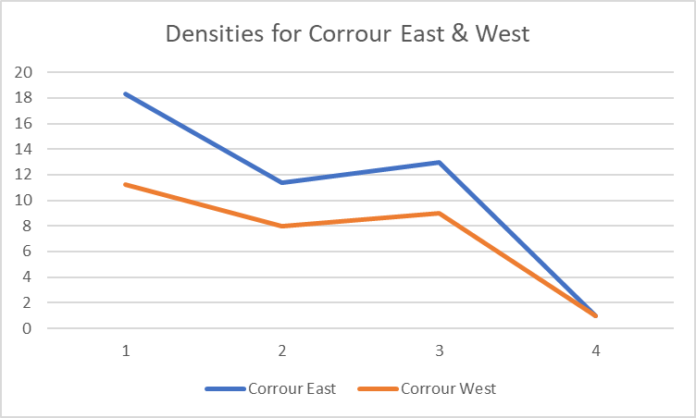

In the graph below, the JMT Ben Nevis property is lower than the 2 X Jahama estates properties, although broadly the same in 2006.

The figures for Mamore and Killiechonate were amalgamated in 2006, so they may have been different then as opposed to what has been shown here, but the deer counts suggest a very obvious increase in deer density across both these properties since then, with Mamore now above Killiechonate, having previously been less.

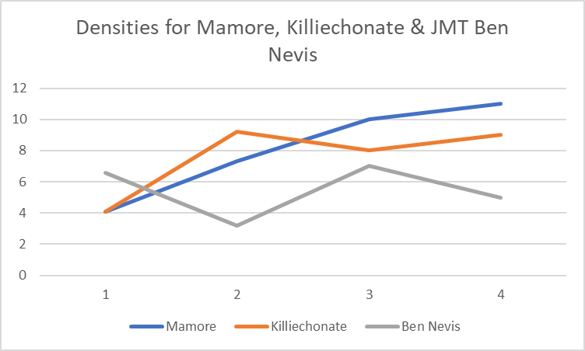

Most of the trends above are very clear in general terms, but to get a better feel for the detail, it was decided to take the population counted in 2017 and project this through to 2021, and then compare the figures on an estate by estate basis to the counted 2021 figure. This would hopefully provide some information on movement within the area. The important caveat is that recruitment counts have not been done in the intervening years, so approximate average values are given for this.

Mid West DMG
 | 2021 Projected Spring Population
 | 2021 spring stag | 2021 spring hind | 2021 Stags Actual | 2021 Hinds Actual | Stags | Hinds | Stags | Hinds
Property | Pop | pop | Count | Count | Diff | Diff | Diff | Diff
Ardverikie | 781 | 759 | 663 | 883 | - 118 | 124
Camusericht | 482 | 459 | 319 | 446 | - 163 | - 13
Ben Alder | 722 | 792 | 405 | 557 | - 317 | - 235
Dunan | 197 | 476 | 27 | 225 | - 170 | - 251
Cruach | 78 | 179 | 153 | 268 | 75 | 89
Corrour | - 668 | - 297 | 38 | 93 | 706 | 390 | 35% | 35%
East Total: | 1592 | 2368 | 1605 | 2472 | 13 | 104 | -94 | -3
Mamore | 611 | 799 | 323 | 1016 | - 288 | 217
Killiechonate | 763 | 655 | 552 | 797 | - 211 | 142
JMT Ben Nevis | 20 | 8 | 9 | 60 | - 11 | 52
FLS | - 530 | - 240 | 21 | 19 | 551 | 259 | 35% | 35%
West Total: | 864 | 1221 | 905 | 1892 | 41 | 670 | 89 | 719
DMG Total | 2456 | 3589 | 2510 | 4364 | 54 | 774 | -5 | 716

In the table above, the orange figures are the spring 2021 population projected from 2017, and the green figures are the helicopter count in 2021. When doing such an analysis, it is often useful to check how the projected population differs from the counted population at the later date.

For the eastern side as a whole, a recruitment rate of 32% is used, recorded cull information is incorporated, and winter mortality of 2% for stags & hinds and 6% for calves is used.

The difference between projected and counted is very small indeed (13 stags and 104 hinds, with even the latter figure being a very small proportion of the counted population. Even at a higher recruitment rate of 35%, the difference is not that great. This suggests that the eastern side as a whole is fairly well contained, and our understanding of the dynamics of that overall area are good.

Within individual properties, Ardverikie, Camusericht and Dunan have fewer deer than they might expect to have given what they have been culling, and this difference is very much more pronounced for Ben Alder. The figures suggest that Cruach have slightly more deer than you might expect given their culling levels. Obviously, Corrour have culled many more deer than an estate population model might suggest was possible, more or less balancing out the reduced populations elsewhere. This suggests that their big cull has influenced the eastern side of the DMG, but not the west.

For the west, a higher recruitment rate of 38% is used, but the figures are replicated for 35% as well, and don’t show too much difference. The stag figures show both Mamore and Killiechonate having a significant net loss of stags, seemingly being picked up by the FLS areas. The JMT cull figures are more in line with expectations. So, this suggests that stag numbers in the west overall can be explained fairly well by existing culls, and there is not much evidence of immigration or emigration from the area overall.

However, it is very different with the hinds, with over 700 more hinds counted than projected. However, the figures from the east suggest these hinds are not moving from there. The most likely explanation is that a lot of hinds are hidden in woodland areas, and therefore, it is possible to shoot a lot more than a population model might suggest was possible. This is important information to bear in mind when setting culls for the west side of the DMG.

Red Deer Cull Data
There is good cull data within the Mod West DMG area going back to 1998-99, with only a few gaps in the sequence, mostly in the very early years. The only other inconsistency is that Ben Alder is sometimes reported on its different beats, and sometimes all together.

The graphs below show some of the trends over that time period, firstly at the wider level, and then for individual estates.

On the stag cull, you can see below that in the west the cull is very stable, perhaps creeping up slightly over 20 years, but perhaps falling away in the last 3-4 years.

In the east, the stag cull increased gradually for the first ten years or so, then declined for 8-9 years. There was then two very large stag culls on Corrour within a four year period, leaving the 2021 cull much lower indeed.

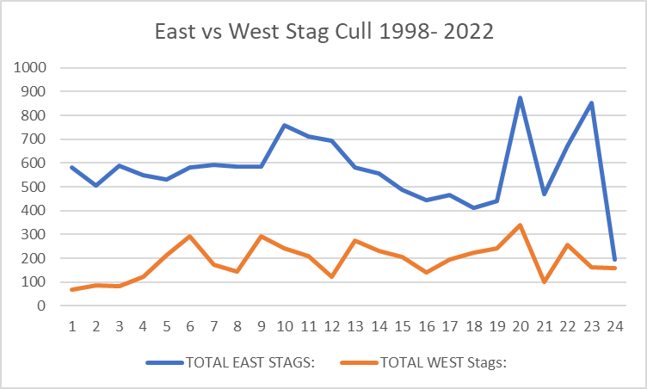

For the hinds, below, the cull in the west is very stable indeed. For the east, while the 2 X large Corrour culls are apparent in recent years, the longer term cull is definitely going down, dropping to a very low level in 2021-22. We can speculate from this that people are reacting to the Corrour cull by being more cautious themselves, erring on the safe side. However, it is quite likely that there will be a consequence to this further down the line.

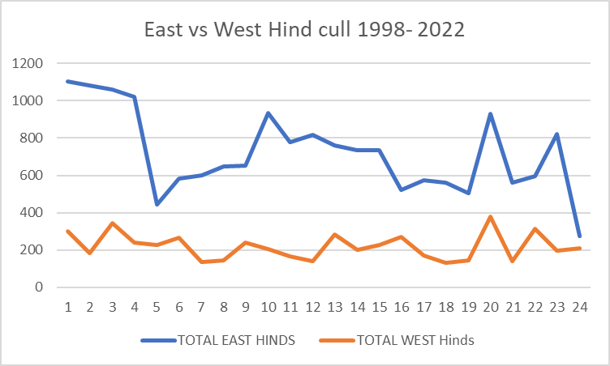

For stags and hinds across the DMG as a whole, except for the first few years, you can see that in terms of both numbers and pattern, the culls are very similar, with the 2021-22 culls being at an historic low.

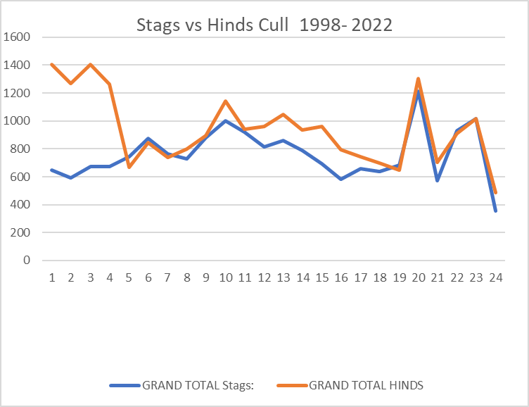

In terms of calves culled as a proportion of hinds, except for the first few years, you can see that the proportions are very similar. Recruitment data from 2022 suggested recruitment was much higher in the west than the east, but this may have been an anomaly. The proportion of calves being culled is not the same as the recruitment rate however, as some people may choose to cull hinds with calves, and others prefer to cull yeld hinds. Certainly, in recent years, some properties have shot hinds with a very low proportion of calves, well below the probable recruitment rates. So, there is only so much that can be read in to this, other than to try and record recruitment carefully each year across the whole DMG area to factor in regional variation. There is a very obvious upwards progression in this graph, showing that the proportion of calves being culled is increasing.
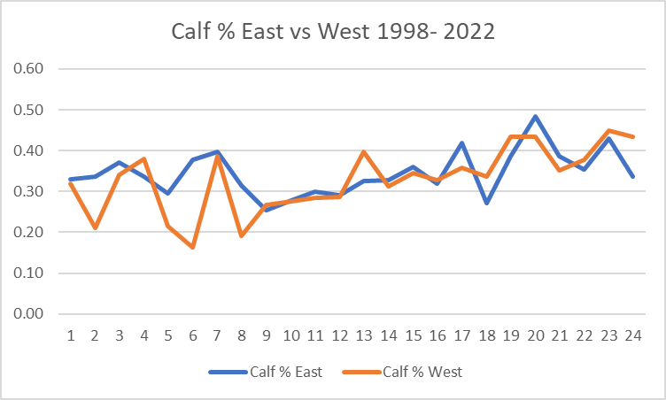

For Ardverikie, below, you can see both the stag and hind culls are broadly decreasing over the period of time, but this is in line with the counts, which are also decreasing at approx. the same rate.
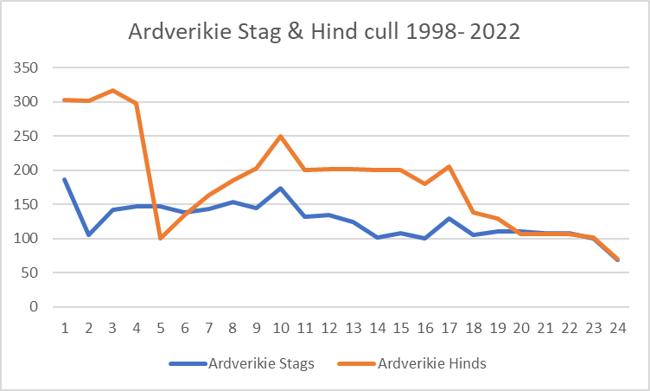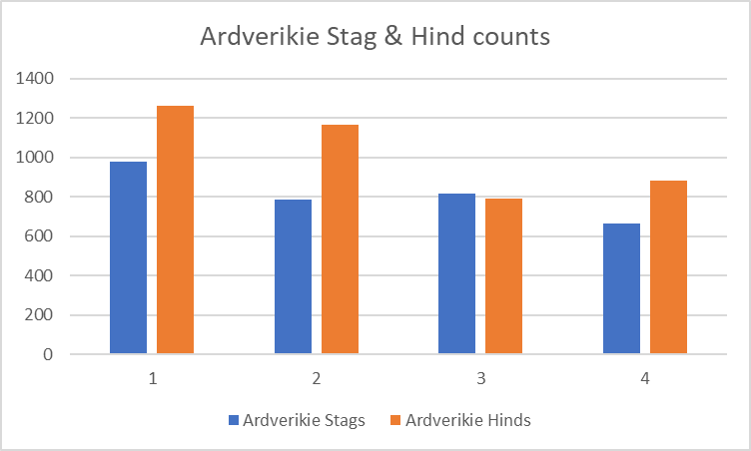

This broad pattern is the same for Ben Alder, with both counts and culls definitely showing a long term downwards trend, although the year to year variation in cull seems to be more variable.

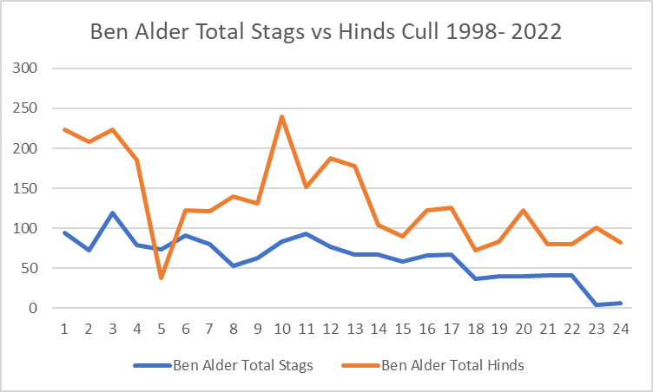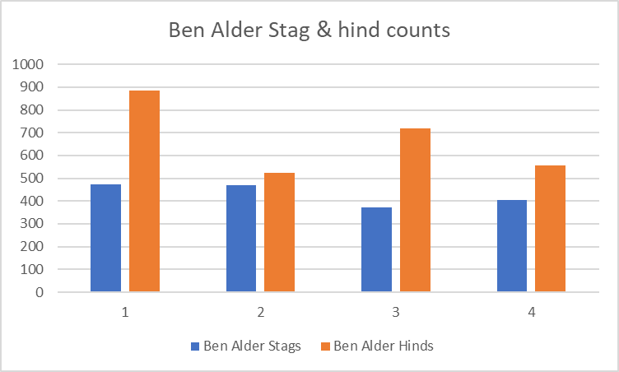

The pattern at Camusericht is different. The decline in culls is much sharper, especially in recent years, but while there is a modest decline in stags, the hind count is actually going up.
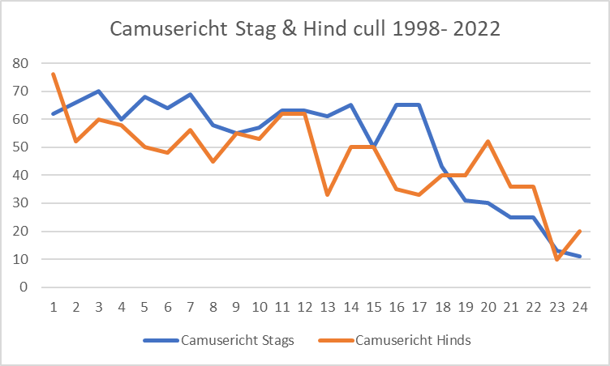

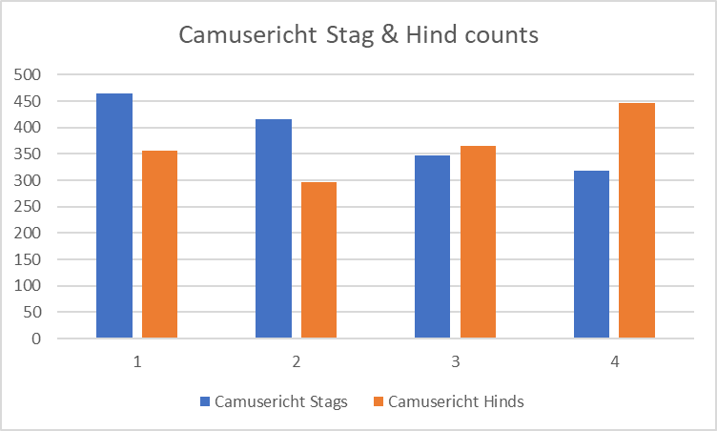

At Dunan, the long term trend is also obviously downwards, except for one year with a very high hind cull 4-5 years ago. Stag numbers have always been very low. The hind count was increasing up to 2017, but has fallen away very sharply since then.
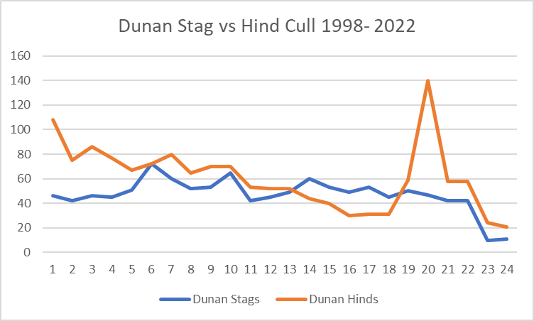

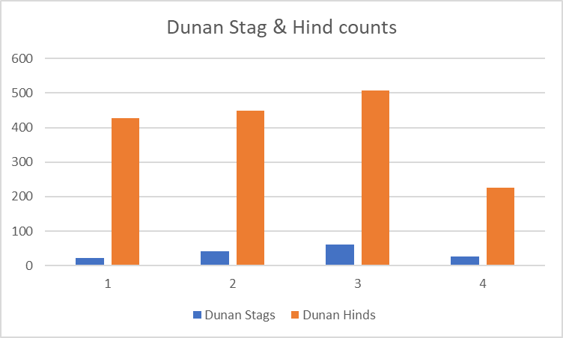

There has been a long, very gradual decline in both hind and stag culls on Cruach. Hinds counts have clearly been going up however, although stag numbers are more variable.

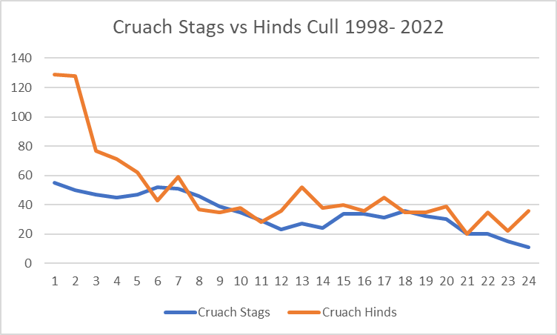

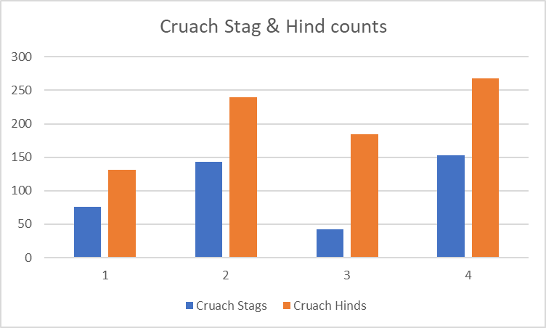

Both stag and hind culls on Corrour increased, then decreased, before the two very arge culls within the past few years, before falling away in 2021-22. Over this period, hind numbers did appear to gradually be coming down, with stags falling away, then recovering again. The 2021 showed very low numbers of animals.
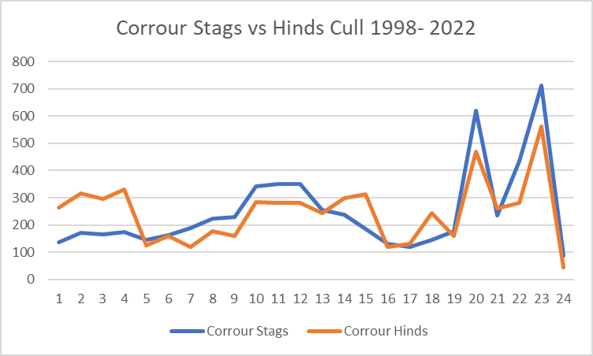

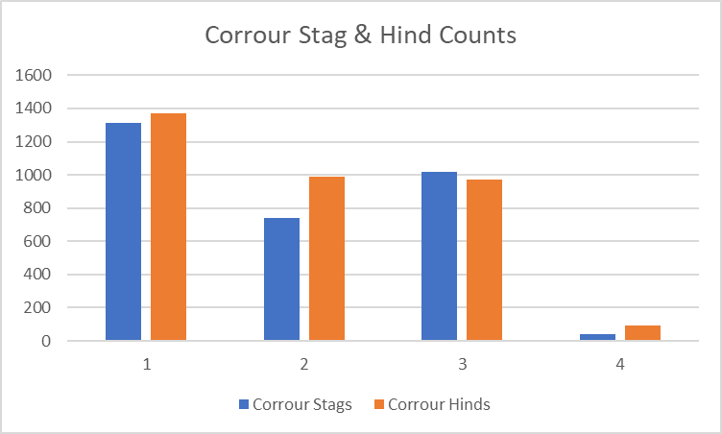

As with, other properties, the Mamore cull was highest at the beginning of this period, gradually declining through to present, but with significant variation within this.

The stag numbers appear to be increasing gradually throughout, but hind numbers appear to be increasing very significantly indeed, vastly outnumbering the stags.

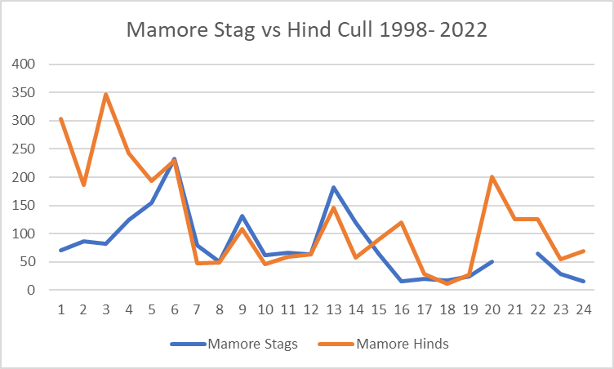

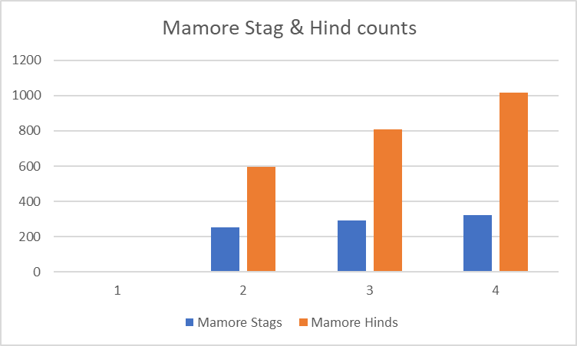

The Killiechonate stag cull has been coming down gradually since the middle of the period.

The hind cull has been much more variable. The hind count at Pt 21 is a data error.

In terms of counts, the stag numbers appear stable, perhaps increasing a bit. The hind count also seems to be increasing.

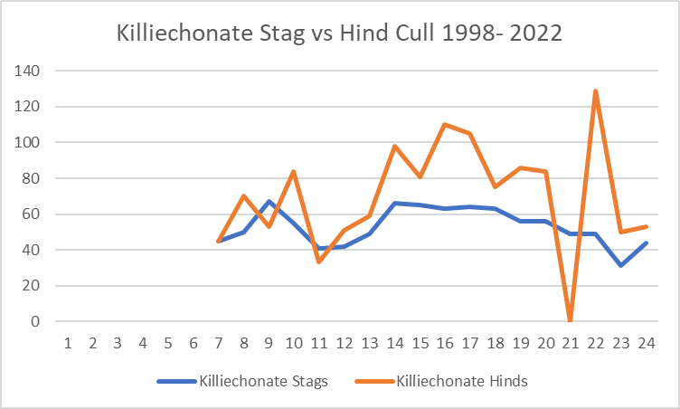

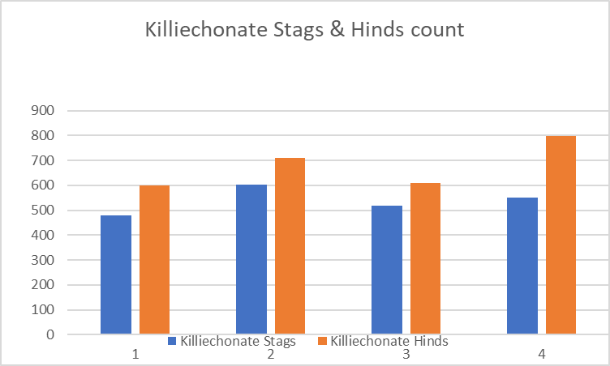

For JMT Ben Nevis, both stag and hind culls have been gradually increasing over the period, with very much higher culls in the past two years, particularly for hinds.

In terms of counts, stag numbers have always been fairly low, with hind numbers obviously much higher, but possibly going down a bit.

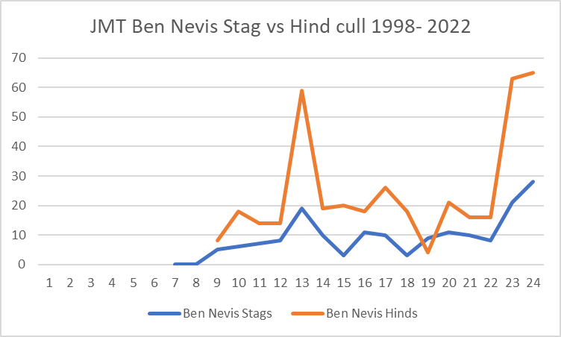

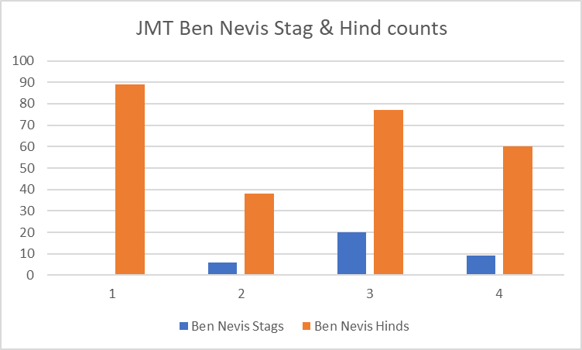

FLS stag culls have been gradually increasing over the period, but with a lot of annual variation. The hill cull is generally much lower, with little obvious trend up or down.

No count information is given as this would be misleading in a woodland environment.

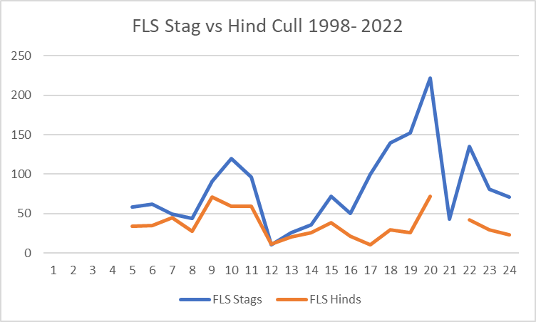

At the wider level again, all properties to the east (excluding Corrour) have shown reducing stag culls across the whole period.

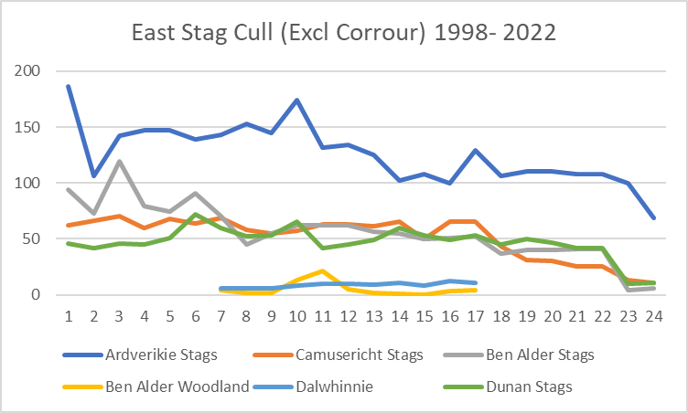

Likewise, the hind cull has generally been coming down on the eastern side, across all properties bar Corrour.

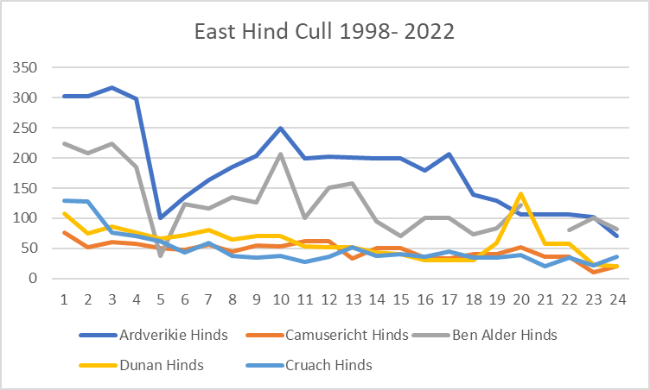

In contrast, the stag cull to the west has been much more variable, with different things going on in different properties. In general, it seems the Jahama Estates have been coming down, with FLS in particular has been going up significantly.

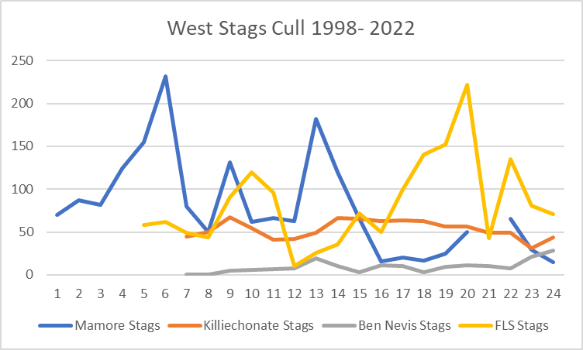

Likewise, a very mixed picture for hinds in the west, although the Mamore cull is very significantly lower now than it was right at the beginning of the period.

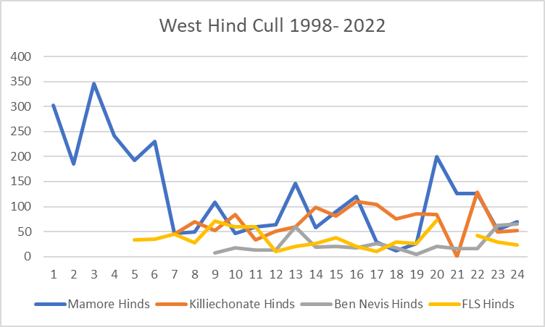

Hinds in the west as a whole are definitely climbing sharply, stags much less so.

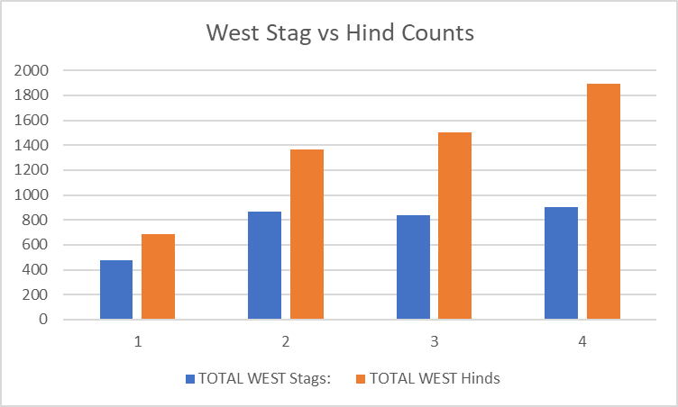

By contrast, both stags and hinds coming down in the east as a whole.

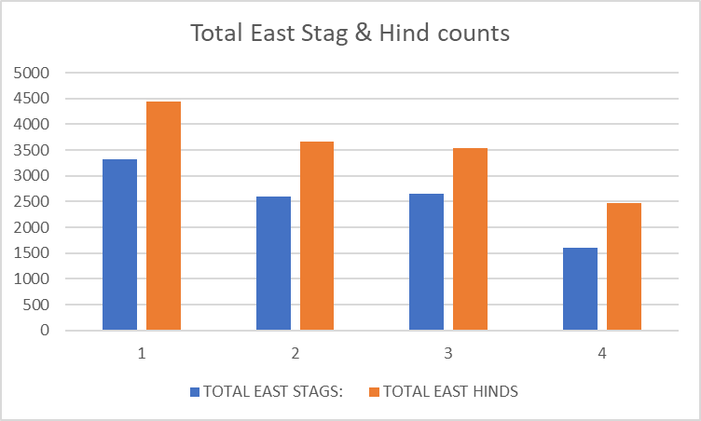

East stags definitely coming down, west stags perhaps coming up a bit.

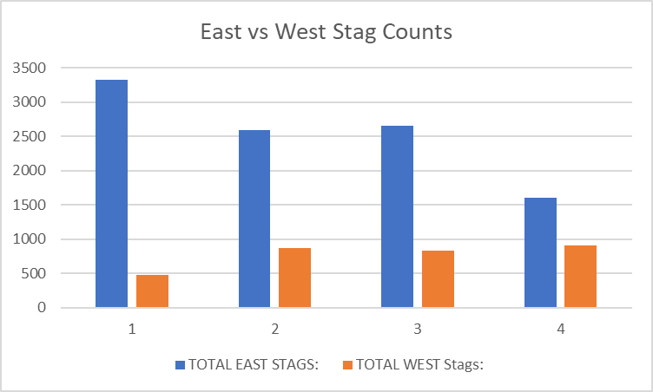

Hinds coming down in the east, going up in the west, although east hind still greater in total numbers.

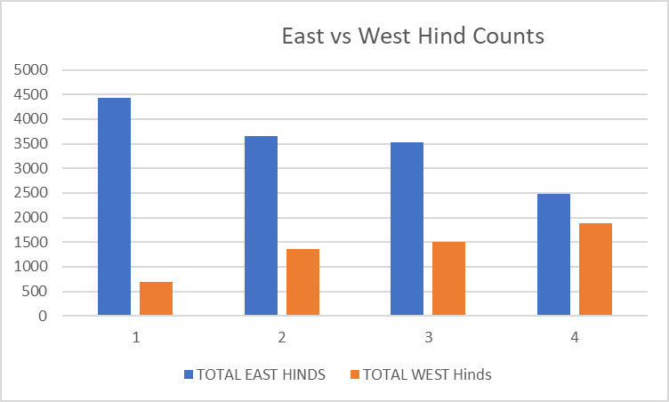

Red Deer Management Issues

The following issues have been identified by analysis to the questionnaires returned by MW DMG members as part of the process to update the current deer management plan.

Seeing past recent Corrour Culls
Conservation management efforts on Corrour have dominated the DMG area for 10-12 years, and there have been two very large culls there in the last four years or so, the most notable being in 2020-21. The location and size of Corrour in the middle of the DMG means this has affected a lot of other members, who have struggled in many cases to know how to deal with this. However, during the review of this deer plan, it is apparent now that many of the other members are developing their own conservation objectives, they are often willing to reduce their expectations on the deer front, and to work out strategies for keeping more of their deer on their own ground.

It therefore appears that objectives are converging, not diverging. It is also apparent that there are actually enough deer in the area to provide people with the objectives that they say they want, it is just that the age profile is younger than they would like, and the distribution is not always right. It is also the case that going forwards, the key areas on Corrour are also the areas where stags in particular want to gather up in winter and spring.

Corrour have indicated that they are happy to cull in accordance with an agreed plan, so the challenge for the DMG as a whole is to try and manage a period of transition, culling some animals at a younger age to try and create a better age structure without letting numbers increase again. It is appreciated that this is a difficult task, and will require monitoring of culls, recruitment and habitat response so that people can determine whether progress is being made or not.

Within this plan, people are being asked to provide cull and recruitment information on a greater number of Reporting Units, so that it is more apparent what is happening and where.

Reluctance to work as a group
As suggested above, properties have been working out their own strategies for retaining some deer and becoming more resilient against activity on Corrour. While this is a good thing, efforts would be more effective if they were better co-ordinated. There appears to be little reference to others when deciding upon cull levels. Overall, it appears that several properties are being more cautious than they need to be, and the likely result of this will be that numbers go up again, probably leading to problems again. There is clearly a period of transition ahead within the MWDMG area, and the change for the DMG will be to work through that together.

Increasing deer population in the west
As outlined previously in this document, the deer population in the west of the DMG area has increased 2.5 times in fifteen years, and it appears that current cull levels are not adequate to remove the annual recruitment. Going forwards, it is important to increase culls to prevent any further increase in population, and then increase this to reduce the population to a more suitable level. At present, stag requirements in the area are very low, so there is little threat to sporting management.

Risk to designated features in the west
While many of the designated open ground features in the west look to be in good or recovering condition, many of these have not been evaluated for many years, and the condition stated is often from a time when deer numbers were much lower. An increasing deer density is therefore likely to be putting pressure on many of these open ground habitats, and a future Site Condition survey may well reveal this to be the case.

Native woodland impacts
Related to the previous point, most of the designated woodland features and native woodlands at higher impact more broadly are in the west of the DMG area, and the increasing population can only mean that the condition of these will be deteriorating, especially those areas that where already in poorer condition fifteen years ago when the population was a lot less. Woodland habitats on the western side of the DMG are therefore an important consideration within the DMG area.

Difficulty in accessing many areas
There is no doubt that much of the landscape within the DMG area is very challenging, and access to many areas is extremely difficult. This is a particular problem if the winter is relatively mild, and deer are staying out on the higher tops. In such situations, achieving the required cull is difficult. Harder weather will, in general, make the deer much more accessible.

Maintaining a suitable population in the east
The current density of c 8 deer per sq km in the east is broadly suitable for the range of designated habitats, and will, in theory at least, give people the sporting requirements that they have. The current situation with designated habitats is generally positive. However, the distribution of deer is difficult to match to local demand and conservation objectives, with some areas with more than they want, and others with more than they need. Achieving the transition is the priority consideration to try and get right.

The risk that east population will increase again
Several properties on the eastern side of the DMG are being cautious about what they cull, perhaps understandably, but the risk is that if annual recruitment is not removed that the population will increase again, and this will become a threat to designated open ground habitats, or that more deer will be culled on Corrour again.
Maintaining something like the current deer density in the east will be a key challenge for the group, and there needs to be a recognition that some sort of transition period will be required, probably with people shooting some deer that they would not normally remove in order to correct the current age profile and distribution.

Habitat Monitoring
There is generally good capacity for habitat monitoring within the DMG area, although sometimes there is uncertainty as to how many plots should be completed, or when these should be done. A habitat monitoring plan is set out in the Working Plan which accompanies this document.

Recruitment counting
There is very little recruitment count data available within the DMG files, although members carried out a good count in 2022. This data is important because the recruitment count obviously varies considerably across the area (20-45%), even within one season, and can be quite high as well, possibly more so than expected. It is also interesting that in 2022, the highest rates were in the west on the highest ground, which is not what you might expect, although that is where much of the better hill vegetation is.

So, getting a good count across the full extent of the DMG is very important in understanding how many deer are coming in to the population each year.

There is a suggestion from data showing proportion of culled calves, that the recruitment rate may be increasing in the MWDMG area, although it may be that a higher proportion of hinds with calves are being culled, and it is this that is generating the apparent increase.

Fewer opportunities for younger stalkers
Two properties have indicated that they will no longer be taking on trainee keepers due to the reducing deer numbers in the area, and the reduced opportunities for income that this implies. It was also apparent after the pandemic that a number of keepers were anxious about the longer term viability of their jobs, and that this was causing uncertainty and stress.
For these reasons, it is very important to be able to plan ahead and try to project what deer might be available going forwards.

At the moment however, there does appear to be enough deer around to give people what they want, although the location of those deer and their age structure may not be what people want. There is therefore a period of transition to be overcome, and that is the challenge for the group to get right.

Deer around Kinlochleven
This has become more apparent as a problem in 2021-22, with deer appearing in and around the village. As with similar situations elsewhere in the Highlands, part of the problem is that some people want to have deer, and will actively feed and encourage them. Others see the damage they cause, and the potential for Lyme’s Disease and other problems. The problem briefly got in to the Press in 2021-22, but the property involved are taking action to try and reduce overall numbers in that area, including with relevant authorizations. However, it is a difficult problem to overcome.

Access pressure
Although there are a number of popular Munros within the area, there is relatively little deer disturbance arising from this, and members have indicated that this is something that they are able to work around without too much difficulty.

Other Deer Species
Deer cull records show that there are small pockets of sika deer resident within woodland blocks in the north of the DMG area, with occasional travelling animals sometimes being culled around Loch Rannoch to the South.

There are no fallow deer within the area.

Roe deer numbers are generally low throughout, increasing in the woodland areas, but with little commercial use being made of these.

Group policy regarding these three species is as follows:

Sika Deer
Sika deer will not be encouraged within the Mid West DMG area, and all properties are encouraged to cull whatever animals that might be identified as such during normal operations, and report to the group. If necessary, out-of- season licenses/ advice should be sought from Nature Scot as a matter of priority when such animals are causing damage to timber, crops or identifiable aspects of the natural heritage. It is accepted that some of the resident animals may have to be contained within their existing locations, and that removal of the species is not practicable.

Fallow Deer
Fallow deer are not present within the Mid West DMG area.

Under current legislation, the introduction of any such animals outwith their normal range would constitute an offence.

Roe Deer
Roe deer are present in small numbers within woodland habitats, with open ground conditions generally being too harsh for the species. Members will look to maintain current numbers through maintenance culling, recognizing that weather conditions and open ground habitats are almost certainly the most effective means of population control.

No information regarding roe deer populations is available within the group area as a whole, although FLS will have information through dung counting within the main forested blocks.

Roe Deer Management Issues
There are not considered to be any significant roe deer management issues within the group area.

9. Grouse Moor Management
Cruach and Dunan manage their moorland areas for grouse, but overall expectations are generally modest. Overall, most DMG members will make use of grouse if they are there, but recognize the marginal nature of this enterprise, given their geographic location this far to the west.

10. Hill Sheep Management
There are only c 1700 sheep present within the DMG area, almost all within Killiechonate on Jahama Estates on an agricultural tenancy, and on a number of crofts. There are no sheep present anywhere else in the DMG area, including the whole of the eastern side. Most sheep have been removed from the area in the more distant past, beyond 20 years.

Cattle
Cruach graze cattle on their ground, but there are few anywhere else in the area.

The Mid West DMG area is therefore relatively unusual in that there are virtually no other large herbivores present other than red deer.

11. Forestry & Woodland Management
In addition to the publicly owned woodlands managed by FLS, there are extensive conifer blocks on Corrour, Ardverikie, Ben Alder and Cruach, all of whom manage at least some of these areas on a commercial basis. Dunan have extensive young planted native woodlands, Jahama have a very large native regeneration scheme by Loch Leven, woodland regeneration and restoration is a key management objective for Corrour, and the John Muir Trust have native woodland regeneration objectives in Glen Nevis.

Overall, there are about 12,700 ha of conifer woodlands, covering about 10% of the DMG area, with a much lesser area of about 1700 ha of native broadleaved woodland, just over 1% of the area.

12. Supplementary Deer Policies
Nature Scot Authorisations
Members will be encouraged to share information within the Group on any out of season and night shooting authorizations from Nature Scot, over some or all of the land where they carry out the deer control.

The vast majority of deer are culled in season, but deer marauding on farmland in spring can sometimes occur and dealing with this is an important consideration in retaining some flexibility within the Group area. OOS is also used to remove stags from areas of conservation importance in the spring months, and may also become increasingly important in protecting native woodland regeneration.

Winter Mortality
Members will monitor and report any significant levels of winter mortality to the Group, or any significant health issues encountered. It is considered that mortality within the group is approx 2% for adults and 6% for calves in their first year. Recruitment is approx 35% although this varies significantly across the sub areas, and it is important to quantify this within each area individually. These figures are used in the current population models for MWDMG.

Deer Related Traffic Incidents
It is agreed by the Members that they will keep records of any collisions between deer and cars or other vehicles in their area together with relevant information (eg. location, species of deer, fate of deer, damage to vehicle, human injuries), while also recording dead deer in their annual cull returns and where appropriate, larder sheets. Members may also wish to contribute to the national project collating RTA reports which can be accessed at http://www.deercollisions.co.uk Members recognize that deer related traffic accidents are receiving more attention nationally and that there may be places in the Group area where deer can be a particular hazard. Within the MWDMG area, the only significants incidents happen on the stretch of road between Spean Bridge and Fort William. Obviously, there are no roads in the interior of the DMG area, and most of the periphery to the DMG area is provided by a number of significant lochs.

A summary of such collisions can be seen at MW DMG DVC map, covering the period 2000- 2018.

Deer Fences
Attaining an up to date picture of the status of these fences should be a priority for the group. Almost all significant woodland areas within the Group area are fenced off from deer, although many areas are retained as deer shelter, and a number of pole-stage plantations have been opened up for deer access in recent years.

Deer densities are such that it is generally held within the MWDMG area that new plantings/ restocked areas be fenced, but there are obviously large regnerations initiatives on both Jahama Estates and Corrour, as well as on the JMT property on Ben Nevis.
Group members will take account of the Joint Agency Fencing guidelines, which are shortly to be renewed.

Supplementary/ diversionary Feeding
There are currently five DMG members who feed deer, with the objective being to try and maintain stags in areas where they are unlikely to be culled by others.

Members currently feeding deer are:
Ardverikie
Ben Alder
Camusericht
Cruach
Dunan
Killiechonate

Members agree that they will inform the Group if they decide to undertake any such feeding in period of this Plan, or if any significant changes are made to current practice. All deer feeding which takes place will comply with industry Best Practice.

Venison Marketing
Larder provision within the group is generally good. Group members share a commitment to high standards beyond the larder door. All group members are members of the venison quality assurance scheme (SQWV), one of very few DMG areas in Scotland where this is the case. As a matter of general principle, Members also support the local consumption of locally shot, high quality venison.

A wide range of game dealers and processors are used by group members, with no one organization having a dominant role.

13. Non- native Species Policy
At present, as well as the native red and roe deer, there are known to be occasional sika deer within the DMG boundary.

There are no fallow deer within the Group area, and there are no known plans to introduce any.

Sika Deer
There is no desire from any Group members to see Sika deer become established in the area, although it is apparent from cull returns that this is the case to a limited extent among some woodland blocks. For this reason, all Sika deer will be culled within accepted seasons, and such culls reported to the Group for the information of other members.

Other non- native species
Sightings of any other deer species, notably muntjac, will be reported immediately to both the deer group and to Nature Scot, and efforts made to remove such animals as quickly as possible. Group members are encouraged to cull such animals first, and report them later.

There are no wild goats within the area.

Ild boar are present within the wider area, and may well be present within the DMG area, at least in the north. However, their numbers at present will be very low.

14. Communications Policy
The Mid West DMG is committed to the transparent communication of all relevant information to its members, to government agencies and to the public more widely, with the caveat that some sensitive data will be distributed to group members only.
The primary source of information about the Group will be on its website: https://midwestassociationdmg.deer-management.co.uk/ and on which all information relevant to the group can be located. This will include the deer management plan and associated maps, a constitution, minutes of group meetings, and population models.
All enquiries to the Group should be made through the Group Secretary via email, or if necessary, to the Group Chairman. Their contact details are:

Mid West Deer Management Group
Group Secretary: Victor Clements
victor@nativewoods.co.uk
Tel: (01887) 829 361

Chairman
Roddie Feilden
Roddie@feilden.org

The contact details for individual properties will not be available as a matter of course through the Deer Group or website, although the Secretary can put you in touch with the relevant people if appropriate to do so. No cull information on individual properties will be made available outwith the membership of the Group and Nature Scot.

Every effort will be made to deal with non- emergency issues within 10 days. More pressing issues will be dealt with promptly if appropriate.

For more long established or strategic issues, it may be appropriate for the issue to be brought up at a deer management group meeting, which take place at six monthly intervals. The Chairman may recommend this to you. The spring meeting will be an open meeting to which anyone is entitled to attend. Items for inclusion on the Agenda for such meetings must be submitted to the Group Chairman three weeks in advance of the meeting, otherwise they can be taken up under “Any Other Competent Business”. Any item that is not deemed appropriate for discussion on the Agenda will be addressed in some other, appropriate fashion. Please respect the judgement of the Chairman if his view is that, in the first instance, an issue should be dealt with outside a formal group meeting. This may be because of time pressures, or the nature of the issue at hand.

All local Community Councils and other relevant interests will be made aware of meetings in advance, and invited to contribute to the agenda for these.

Local input on the continuing evolution of the group Deer Management Plan is welcomed and encouraged. Email contacts for local community councils are included in Appendix 2. These details are not being made public through the website, but are available on request to Group members and community interests as required.

Any queries about the running of the DMG can be addressed to Nature Scot, at any of the contact points listed here below:

Nature Scot Contact
Sinclair Coghill is the current Nature Scot Wildlife Operations officer covering the Mid West area: Sinclair.Coghill@nature.scot

Lorraine Servant is responsible for site management within the area: lorraine.servant@nature.scot

For more general deer enquiries: licensing@nature.scot

MWDMG will seek to respond to any requests from media sources or the local public for information, and individual members may arrange, from time to time, appropriate open days and information events if these are requested or deemed to be useful.

MWDMG welcomes comment on all matters either directly or indirectly associated with deer management within the Mid West area.

15. Training Policy
MWDMG encourage and facilitate the attainment of all qualifications and training necessary for the delivery of effective deer management within their area of operation, and support continuing professional development through the adoption of Best Practice Guidance and other relevant courses .
The recognized and recommended industry standard for culling deer is that all those personnel involved in deer management should attain level of Deer Management Qualification (DMQ) Level 1 or equivalent.
As at June 2022, 21 of the 21 personnel involved in deer management in the MWDMG area have obtained this qualification.

The DMQ Level 2 qualification is increasingly held as the de facto industry standard for professional stalkers, which requires the identification, stalking, dispatching and lardering of deer under supervision.
At June 2022, 16 of the 21 personnel involved in deer management in the MWDMG area held the DMQ Level 2 qualification.

For those expected to larder deer and prepare them for the human food chain, industry requirements are that they have attained Trained Hunter status. This is the equivalent of any DMQ course passed after 2006, or an upgraded version of DMQ1 passed before that time.
At June 2022, 17 of the 21 personnel involved in deer management within with MWDMG area had trained hunter status.

All personnel requiring to take deer under special authorizations must be on the Nature Scot “Fit & Competent” register. The requirement for this is to hold the DMQ Level 2 qualification, or DMQ Level 1 plus two references.
At June 2022, 9 X personnel in the MWDMG area required to take deer under authorization, and were on the Fit & Competent register. This relatively low number reflects the fact that the vast majority of deer within the area are culled in season and during daylight hours.

All personnel within the area are encouraged to be proficient in First Aid, manual handling, ATV driving and maintenance and other tasks which are central to their job. MWDMG will monitor the level of skills among staff in the DMG area, and undertake to facilitate any such courses or training that may be necessary to put right any deficiencies that are identified. All estates will support their staff in attaining the agreed standards, especially in all matters relating to Health & Safety, both of personnel and visiting guests.

Group members are encouraged to bring forward any suggestions for suitable training that might be of relevance to the Group as a whole, or to ask for support in arranging training for their staff. The most relevant training going forwards is likely to be in relation to habitat surveying and monitoring work. While many group members are already capable of doing this, others will require some structured training, and the management of such activity across the area will be an important function for the group to be able to undertake.

16. Reviewing the Plan
This Plan provides an agreed framework for a co-ordinated and co-operative approach to deer management in the area. The actual implementation of the Plan will be decided on an ongoing basis at the Group’s spring and autumn meetings, with scope for the Membership to adjust and adapt the Plan to meet changing circumstances. This Plan, with its attendant maps and databases will be circulated along with the Agenda to all group members prior to meetings, any changes actioned, and the revised plan included with the minutes of that meeting, or at a suitable time thereafter. Group members are therefore encouraged to report all changes in contact details, personnel or management practices that might be relevant to the group, or any potential upcoming projects that might affect deer management within the area, even if such proposals are still at a planning stage.
The population models and maps will be updated on an annual basis as required, with the former adjusted so that it is always looking five years ahead.
The Members agree that there will be a more systematic review of the Plan and its provisions during autumn 2028 and thereafter, 2033, and, if considered necessary, the production of a revised edition of the Plan will be actioned at these points.

Part Four - OPERATION OF THE GROUP

The Mid West DMG has been assessed against the DMG Benchmark document developed by the Association for Deer Management Groups in 2014, 2016 and 2019, with an ADMG health check also undertaken in 2018. In this section of the plan, an account is given of how the Group currently meets the recommended operating criteria and, where appropriate, correcting or amending actions are listed.

Area & Boundaries
The boundaries of the group are considered to be appropriate and secure to significant deer movements from elsewhere, although there is some discussion about the relationship with Black Corries estate to the south. The location of the group is shown on the MWDMG Location map. For the purposes of this plan, West and East sub- areas have been defined, and population modelling will be done on this sub- area basis.

There are a number of smaller properties towards the west of the DMG area who are not in the group. The DMG will welcome these areas as members should they wish to join, but they do not affect the broad management picture within the main DMG area.

Action Point
  - Monitor the operation and accuracy of the 2 X sub area population models during the course of this plan, and review as required.
  - Welcome any smaller properties who might wish to join the DMG.

Membership
Almost all of the significant land holdings within the MWDMG area are members of the Deer Group, with the JMT Ben Nevis property being the obvious exception, although they do provide key information, and are copied in to all DMG communications.

Action Points
2.1 Continue to liaise with JMT Ben Nevis re counts & culls, and copy them in to all DMG communications.

Meetings
The group already meet twice a year, and the attendance at meetings is generally good. Nature Scot & FLS attend meetings, and group have demonstrated an ability to take forwards business between meetings. Not all owners attend every meeting, but communications/ correspondence between meetings is good, as required, so overall participation can be considered to be adequate, with both owners and employees contributing well. Going forwards, minutes and agendas of meetings should continue to be published and efforts made to ensure that local interests are aware of meetings and that they have an opportunity to contribute to the agenda as required. The DMG is very easy to find online.

Action Points
3.1 Continue with current pattern of meetings.

3.2 Continue making agendas and minutes available on DMG website

Constitution & Finances
The Group have worked according to a Constitution since its inception, and this was recently updated in 2016 to more reflect the current situation.

In terms of finances, the DMG is currently moving from a system of individual client accounts to an overall DMG account, and this should help with overall budgeting and planning for the future. 2022-23 will be the first full accounting year.

Action Points
4.1 Finalize movement of all finances to DMG account.

4.2 Consider getting accounts independently audited in May 2023.

Deer Management Plan
This new plan is being developed to try and deal with the new dynamic within the group, given the large reduction culls in recent years. The emphasis will be on population modelling and setting of culls, and how to monitor the success or otherwise of that.

Action Points
5.1 Endorse updated DMP by June 2023.

5.2 Ensure a system of communications is in place whereby local interests have access to the plan, and can input to future development of it.

Code of Practice on Deer Management
The code has been endorsed in both this plan and in the constitution of the Group. The terms of the Code will be delivered through implementation of this plan, and the Code will guide all actions taken by the group and by individual members.

Action Point
6.1 Ensure adherence to code at all times, both by the Group, and by individual members. This action point will provide an opportunity for all members at meetings to bring up issues that may be off concern to them re: deer welfare or management.

ADMG Principles of Collaboration
The ADMG principles of collaboration are accepted and endorsed by the Group and by individual members, namely:
- We acknowledge what we have in common, namely a shared commitment to a sustainable and economically viable Scottish countryside.
- We make a commitment to work together to achieve that.
- We accept that we have a diversity of management objectives and respect each other’s objectives.
- We undertake to communicate openly with all relevant parties.
- We commit to negotiate and, where necessary, compromise, in order to accommodate the reasonable land management requirements of neighbours.
- Where there are areas of disagreement we undertake to work together to resolve them.

These principles are also referenced in the Mid West DMG constitution.

Best Practice Guidance
All deer management within the group area will be carried out in accordance with Best Practice guidance, and group members will input to this process and seek to influence it as it continues to evolve.

Data & Evidence gathering- Deer Counts
The DMG area in general is too large and difficult to conduct accurate foot counts, but there have been helicopter counts in 2006, 2011, 2017 & 2021.

Going forwards, the DMG will look to operate a system of population modelling so that approx. deer populations can be maintained between helicopter counts, which may on average take place every 5-6 years.

Given the number of designated sites within the area, Nature Scot may decide to have a helicopter count in the five year period ahead, but this is not essential from a DMG perspective.

In addition, DMG members will conduct recruitment counts on an annual basis, covering at least 1000 hinds across the whole DMG area, looking to take account of any variation that is present.

Forestry & Land Scotland manage the only significant woodland holding across the group area, and make use of dung counting when setting their cull levels.

Action Points
9.1 The group should develop and use population modelling and recruitment counts on an annual basis. Information on mortality shall also be collated on an annual basis.

9.2 Towards the end of this five year period, the DMG to discuss how future counts are to be undertaken, bearing in mind that drone/ satellite counting of deer may well have developed significantly within that period.

Data & Evidence Gathering- Culls
Deer cull information within the Group is very good, with records going back to 1998/99.
Aspirational sporting requirements have been provided by Group members, and a five year population model has been drawn up for each sub population area. From this, culls have been apportioned to each Deer Management Unit area. These population models and cull targets can be found in the Working Plan part of this document.

The broad strategy going forwards will therefore be to set cull levels which ensure a stable population density across the eastern part of the area, but with a reduction cull in the west.

Action Point
10.1 Update the population models and target culls on an annual basis, using recruitment and mortality data collected, as well as actual culls from the previous year.
10.2 Take proper account of reducing demand for stags, and reduce overall population accordingly.

Data & Evidence Gathering- Habitat Monitoring
There is good capacity within the DMG for carrying out habitat monitoring, and most staff are able to do this to the required standard. A proposed schedule starting in 2023 is included in the Working Plan associated with this plan.

As well as the open ground habitat monitoring, Corrour Estate also monitor areas of woodland regeneration. To date, progress in most of these areas has been slow, but the required deer densities have only recently been achieved, so these areas will take some time to come away.

Action Points
11.1 The DMG should work to deliver the suggested monitoring schedule in the Working Plan associated with this document.
11.2 Corrour to continue with woodland regeneration monitoring, and report back results to group.
11.3 HIA results to be collated annually across all members, and distributed back to all.

Competence
Of the 21 personnel involved in deer management within the MW DMG area, the following qualifications are held:

DMQ Level 1: 21
DMQ Level 2 16

17 personnel hold trained hunter status, and 9 personnel are on the SNH “Fit and Competent” register. Note: in this latter case, personnel only need to be on the register if they are applying to cull deer under authorization at night or out of season. The greater number of stalkers within the group do not apply for such authorizations, and therefore do not require to be on the register.

Office bearers from the DMG have attended courses ran by the Association of Deer Management Groups in relation to operation and leadership within local groups.

Action Point
12.1 DMG members will seek to ensure that DMQ Level 1 and Trained Hunter status are delivered as the now accepted industry standard for all personnel involved with deer management within the area, and encouragement will be given to professional stalkers to achieve DMQ level 2.

12.2 Training and support will also be sought from ADMG where that is required to help with running of the Deer Management group.

Training
A Training Policy is included earlier in this document.
Action Points
13.1 Promote and facilitate the uptake of appropriate deer management qualifications.
13.2 Be aware of the ongoing development of Best Practice Guidance and any new techniques or standards that arise from that.
13.3 Review training needs on an annual basis at spring DMG meetings. Health & safety is already on the Agenda of meetings.

Venison Marketing
The quality of deer larders across the DMG is generally very good, and all properties are members of the Scottish Quality Wild Venison (SQWV) scheme, one of very few DMG areas in Scotland where this is the case. The DMG therefore scores very well on this point.

Action Points
14.1 The DMG members will work to maintain SQWV accreditation, and retain the high level of venison production which already exists.

Communications
A Communications policy is included in an earlier section of this document.
The annual communications strategy will involve making all relevant documents available through the ADMG and Mid West DMG websites, including notices to local stakeholders and the opportunity to contribute to the Agenda of meetings, holding one open meeting a year, answering all requests for information from the media and arranging open days and demonstration events where these are appropriate.
All local stakeholders, including community councils have been consulted on the development of this plan. See MWDMG Community Councils Map.

Action Point
15.1 Implement the communications strategy as agreed, and ensure a mechanism is in place for dealing with business and issues between meetings.

Part Five - PUBLIC INTEREST OUTCOMES

The Mid West DMG has been assessed against the DMG Delivery of Public Interest document developed by Scottish Natural Heritage/ Nature Scot and the Association for Deer Management Groups in 2014, 2016 and 2019, and have taken part in the ADMG health check in 2018. In this section of the plan, an account is given of how the Group currently delivers public benefit and, where appropriate, correcting actions are listed.

Develop Mechanisms to manage deer
MWDMG have completed both the Benchmark and Public Interest assessments three times, as above, plus the 2018 health check. The DMG rate very well in this process, with the areas of main weakness relating to setting appropriate culls based on population assessment at a DMG level. One consequence of this is a fragmented decision process which under-estimates the deer numbers present, and a population which risks getting away again.

A series of actions have been identified to be taken forward in a Working Plan, and roles for implementing this have been assigned.

A forward looking deer management plan is in the process of being updated, and is expected to be endorsed in early summer 2023. The plan plus associated documents, maps and minutes of meetings will be published on dedicated MWDMG website space, www.midwestassociationdmg.deer-management.co.uk

Action Points
PIA 1.1 Publish and endorse the new updated MWDMG Deer Management Plan in June 2023.

PIA 1.2 Re-assess the Group against both the Benchmark and the Public Interest criteria once DMP has been endorsed, by June 2023.

PIA 1.3 Review the Working Plan on an annual basis and minute progress and changes.

Delivering Designated Features in to Favourable condition
Designated sites and features within the DMG are documented with Appendix 3, MWDMG Designated Sites. This includes an up to date account of their current status, and suggested actions through which a number of sites in Unfavourable condition can be brought forward in to assured management status.

In general terms, he DMG area is dominated by two large upland sites, the Ben Alder SSSI/ SAC in the east, and the Ben Nevis SSSI/ SAC in the west. In terms of deer management, the Ben Alder site has low impacts, and the priority there should be to broadly maintain the current deer population across the wider area. Around Ben Nevis, there are more woodland designated features, and the deer population appears to be growing. The priority here is to halt that population growth, and implement a population reduction.

Almost all of the other sites are more peripheral to DMG working.

Specific actions will be laid out in the Working Plan at the back of this document.

Action
PIA 2.1 Try to maintain the current deer population/ density on the eastern side of the DMG area in order to maintain the largely favourable status of the Ben Alder SSSI/ SAC site.

PIA 2.2 Halt the rise in deer populations to the west, and then implement a population reduction to get densities down, initially to under 6 per sq km.

PIA 2.3 Implement habitat monitoring to give annual information which will allow DMG members to keep track of changes on and around the above two sites.

Manage Deer to retain existing Native Woodland cover and improve woodland condition in the medium to long term.
There are approx 17,269 hectares of woodland within the MWDMG area, covering 16.5 % of the area of the Group (National Forestry Inventory, NFI). This is very similar to the national average of c 18.5 %, considering the relatively high proportion of high mountain tops and designated features that would not be suitable for planting in comparison to many other parts of the country.

There have been 13,874 ha of woodland creation within the area since 1990, meaning that a lot of the woodland in this area is relatively young. Not all of this area will be recorded in the 17,269 ha figure if it has not yet fully established. There were 1070 ha created under WGS1, 1884 ha created under WGS2, and a much more significant area of 9552 ha created under WGS3. Much of this will lie within the large Kinlochleven natural regeneration scheme, but there is also likely to be a large area of conifers planted in this time period as well. Later on, there was 1188 ha planted under SFGS, and a very modest 180 ha established under SRDP since 2007.

Of this area of 17,269 ha, 9940 ha or 58% is conifers, with the remaining 42% being comprised of broadleaves, mixed woodlands, young plantations or assumed woodland.

Of the total native woodland area of 6274 ha (NWSS), the following herbivore impact levels are currently given:

Low: 1225 ha or 20%
Medium: 3434 ha or 55%
High: 602 ha or 10%
Very High: 1013 ha or 15%

75% of native woodlands overall therefore show low or medium herbivore impact levels. This is a very positive position within Scotland as a whole, and much better than the other west coast DMG areas to the north west.

Native woodlands as a whole are now considered to be in satisfactory condition by Nature Scot if herbivore impacts are in the low or medium categories, canopy cover is greater or equal to 50%, native species comprise more than or equal to 90 %, and invasive species comprise less than or equal to 10%.

Within the MWDMG area, the majority of the woodland area at High and Very High impacts lies along the northern boundary around Spean Bridge. This area has the only significant numbers of livestock within the DMG, and focused deer control measures have tended to be elsewhere.

Actions
PIA 3.1 The DMG need to concentrate on achieving deer reductions in the western part of the area, as that is where the majority of heavily impacted woods lie, and also where all the important designated woodlands are as well, many features of which are in Unfavourable condition. However, an initial reduction to aid open ground habitats is required first.

Demonstrate DMG contribution to woodland expansion target
As noted in previous section, there has been a significant increase in woodland area within the MWMG over the past 30 years or so, with 180 hectares being established under the Scottish Rural Development Programme (SRDP) since 2007, 1188 hectares being established under the Scottish Forestry Grant Scheme (SFGS) since 2003, and a much more significant 12,503 hectares being established under the Woodland Grant Scheme (WGS).

This woodland expansion amounts to 13,874 hectares in total, a very large proportion of the woodland area today. However, very little woodland has been created more recently under SRDP. This is notable in such a large area, that woodland creation has not been an obvious priority at this time. However, it may be more accurate to say that the priority for most members has been to secure what was started in the previous periods, and this was very significant indeed. It is important to add that during the past 15 years or so, the key management objective of Corrour Estate has been to reduce deer numbers and regenerate native woodland. Those efforts are still at an early stage, and it is not possible yet to confirm an area of secured regeneration. That is likely to happen in the ten years ahead.

During the production of this plan, one property has indicated that they are looking at up to 350 ha of new planting in the five years ahead, and it is hoped that during ths period, continued monitoring will give a reasonable estimation of what is likely to be secured on Corrour.

All MWDMG members are encouraged to give the DMG forewarning of their plans at concept stage so that any necessary mitigation can be undertaken in advance.

Actions
PIA 4.1 MDMG to establish up to 350 ha of new woodland area in next five year period. This area may increase over the period as members investigate additional planting opportunities, and records will be updated as this happens.

PIA 4.2 Corrour to keep DMG updated on their monitoring efforts, and report on the location and extent of regeneration arising.

Monitor and manage deer impacts in the wider countryside
Within the DMG area, it is considered that there are the following areas of a range of broad habitat types, taken from the LCS88 dataset. A full summary of the habitat types can be found in the Excel spreadsheet: Appendix 8: MW Broad Habitat Data. This is a particularly good set of data for this area, with no obvious sections obscured by cloud across the whole area. The data is now over 25 years old.

The main habitats in the group are:

9,313 ha of species rich, smooth and nardus dominated upland grasslands, covering 7% of the DMG area, of which 7302 ha or 78% are outwith designated sites.

17,620 ha of miscellaneous montane habitats, covering 14% of the DMG area, and 66% of which is outwith the designated sites.

56,088 ha of undifferentiated heather moorland, covering 43% of the DMG area, and 70% of which is outwith designated sites.

15640 ha of woodlands, covering 12% of the DMG area, 71% of which was outwith designated sites. Note, the woodland area has increased very significantly since 1988 to 17,269 ha, and will be replaced largely rough/ smooth grassland or heather moorland communities noted above.

16,526 ha of blanket bog, or 13% of the DMG area, 91% of which lies outwith the designated sites.

3953 ha of improved grassland and arable land, covering 3% of the DMG area, 99.9% of which lies outwith designated sites.

Finally, 10,735 ha or 8% of the DMG area is covered by miscellaneous features, the greatest part of which is accounted for by water and cliffs. These misc habitats and features rise to 13% within the designated sites.

The current deer densities across the 2 X sub areas are broadly compatible with with at least some of the various moorland habitats present within the area, with the caveat that the habitats themselves require a range of sometimes conflicting grazing densities, with blanket bog and montane habitats requiring a much lower density than the upland grassland communities. We know that HIA undertaken around the designated Ben Alder site shows largely low impacts. This work was independently carried out in 2021, and concentrated on blanket bog habitats. We might expect the seemingly increasing population in the west to be impacting upon habitats here, but there is no evidence of this so far, the only evidence of high impacts being within woodland habitats.

Action Points
PIA 5.1 An agreed monitoring programme for these habitats will be updated and included in this plan by spring 2023.

Improve Scotland’s ability to store carbon

Within the Group area there are approx 17,269 hectares of woodland and 16,526 hectares of peatlands. These are the two habitat types of most relevance to carbon sequestration.

As previously discussed, a very high proportion of the woodland area is under active management in the Group, and the forest area has increased by over a quarter in the past 25 years. The majority of owners have a Forest Plan or a woodland management plan in place, both of which look at the full range of woodland management options over a twenty year period.

During the production of this plan, members were asked about potential planting options going forwards. It is estimated that Group members will be looking to take forwards 350 ha of new woodland creation in the next five years, in addition to whatever regeneration may arise on Corrour, yet to be determined. This relatively modest area is partly explained by the relatively high area of woodland planted in the previous 20 year period.

There are extensive swathes of blanket bog within the DMG boundary, covering approx. 13 percent of the area. The HIA available to DMG members suggests that impacts towards the east of the group are relatively low, and deer numbers are also now very low in the Corrour/ Dunan/ Cruach area where there is also a very significant peatland area. Deer numbers are much higher in the west, but blanket bog is proportionately much less extensive there.

It will be an important part of the planning process going forwards to undertake some habitat monitoring on these areas to understand what condition they are currently in. There may well be a problem in balancing the needs of these sites, which require relatively low herbivore impacts, and those of the species rich grasslands in the group, which require relative higher grazing pressure to remain in favourable condition.

To date, no requests have been made to the Group to contribute to River Basin Management Planning.

Actions
PIA 6.1 Create 350 ha of new woodland planting in the period of this plan, and look to establish what might be secured on Corrour Estate..

PIA 6.2 Carry out habitat monitoring on the blanket bog areas within the DMG before the end of 2023 to determine their current condition and ascertain what management action, if any, might be required to bring them in to good condition.

PIA 6.3 Discourage any burning that might impact on peatland sites.

PIA 6.4 Contribute to River Basin Management Planning as appropriate when requests to do so are forthcoming.

PIA 6.5 Ensure that all woodland planted in the previous period is properly established.

Reduce or mitigate the risk of invasive, non- native species
A non- native deer policy is included earlier in this plan.
Action
PIA 7.1 Cull spreading sika deer so that they do not become established within the area.

PIA 7.2 Report any sightings of muntjac deer, feral pigs or feral goats to Nature Scot. Muntjac deer should be shot on sight if possible.

PIA 7.3 Monitor any fallow deer that become established in the area. They are not currently resident within the group.

Protection of Historic and Cultural Features
There are likely to be many hundreds of sites throughout the DMG area that have archaeological or cultural importance. It is likely that for the majority of these that light grazing by deer and sheep will be beneficial in keeping back rank vegetation growth. At present, the DMG are not aware of any cultural sites that are being negatively impacted by grazing. A greater threat to such features will be woodland creation projects that do not ensure adequate buffer zones around such features, or other development projects. The current woodland grant schemes are very good at flagging up potential sites of cultural or historic value.

Actions
PIA 8.1 The DMG will maintain communication with the local community and look to address any issues that are identified with regards to sites of cultural interest and herbivore grazing.
PIA 8.2 As required by Scottish Forestry, all potential woodland creation projects, including natural regeneration schemes, will be assessed by the applicants for any negative impacts on cultural or archaeological sites.

Delivering higher standards of competence in deer management
A training policy and audit is provided earlier in this document.

Of the 21 personnel who are involved in deer management, all 21 have DMQ Level 1, 16 have DMQ Level 2, and 17 have trained hunter status. Only 9 personnel are on the Fit & Competent register, but this is a reflection of the low number of deer culled out of season or at night by estate staff. The MWDMG area therefore has one of the better levels of training in the country, especially in relation to DMQ Level 1.

Staff within the DMG area have a wide variety of other qualifications and certificates covering other aspects of their work. These include ATV, Argocat, First Aid, Chainsaw, digger, water bailiff, Health & safety, boat handling etc. There does appear to be quite a strong ethos of training and staff improvement across many of the properties within the DMG.

Action Point
PIA 9.1 Continue to support training efforts within the group as opportunities to do so arise.

Contribute to Public Health and wellbeing
Deer Vehicle Collisions are regarded as not being a significant issue throughout most of the DMG area, with the possible exception of the road between Spean Bridge and Fortwilliam. The record of deer collisions from 2000-18 is summarized on the map MW Deer- Vehicle Collisions Map.

Food safety and meat hygiene is best maintained through appropriate training and facilities, and a high proportion of personnel within the Group have Trained Hunter status. All properties operate their larder facilities to Best Practice standards, and all nine or 100% of the properties are SQWV accredited, and operate larders to the highest of standards.

The Trained Hunter training allows personnel to be able to identify any notifiable diseases in deer found in the area. It is not thought that any such problems have been identified in recent years. In any incidences that do occur, the carcase will be held back from the food chain and a veterinary surgeon asked to inspect.

Members are aware of the threat of Chronic Wasting Disease (CWD) in deer being imported from North America, and ADMG and BDS guidance on this has been circulated to the Group.

All members are reminded to be aware of the risk of tick borne diseases, especially Lyme’s Disease, and to communicate such risks to guests and members of the public who might frequent their land through suitable channels.

There are relatively few access/ deer conflicts within the Group area as a whole, as estates know where the pressure points are, and are generally able to work round these.

A number of Group members promote access and provide good information for the public. Beyond the private estates, Ben Nevis and Ben Alder are popular and well known mountains that are always easily accessible, there is a good path network within the wider area, and a number of shops and businesses and guest houses within the area promote walking and access to the countryside.

Action Points
PIA 10.1 Maintain communication with local Community Councils re: DVCs and look to implement any mitigation which may be deemed helpful in reducing local risk..

PIA 10.2 Remind DMG members on an annual basis about the dangers of Chronic Wasting Disease (CWD) and individual members to ensure safety precautions are taken by anyone who has had recent contact with deer or habitats in North America.

PIA 10.3 DMG to highlight the risks of ticks and Lyme’s Disease to their guests and the public more generally through all appropriate channels.

PIA 10.4 Group members and DMG to all promote a positive and welcoming message to all those visiting the area throughout the year, and to contribute fully to the Heading to the Scottish Hills website.

Maximize Economic benefits associated with deer
Allowing that a proportion of the stag cull is a management cull only, it is estimated that the direct sporting value of the stag cull in the MWDMG area is approx £300,000 annually.
Up to 60% of the hind cull is likely to be taken with sporting guests, the value of which might be £100,000 annually.
In both cases, extra value will be obtained from a number of estates through letting of accommodation and other ancillary services, and this can reasonably be expected to be equivalent to the letting fees outlined above. In total therefore, the sporting value of deer stalking in the area is likely to amount to approx £800,000.
Based on a cull of 400 stags, 685 hinds and 240 calves (projected 2022-23 cull), it is estimated that the total value of venison produced within the group area is approx £125,000 annually. This does not take account of the fact that a number of properties market a proportion of their venison directly within the area, and a number of small game dealers operate in close proximity to the group.
The total direct economic value of deer management within the Mid West area is therefore likely to be in the region of £925,000 annually, this before any economic multipliers are considered.

Within the Mid West DMG area, there are currently 21 full time jobs that are either fully or partially involved with deer management, and a further number of personnel who are used at key times of the season. In the latter situation, income from deer management often allows the position as a whole to remain viable. This figure does not include extra seasonal ghillies that are taken on for the main sporting season, or support staff dealing with accommodation, bookings or other necessary support services. The opportunity to have the chance to stalk can often be important to the overall package, whether a deer is actually taken up or not.
Livestock management, general estate work, forestry and rangering are other important activities for those also involved with management of deer.
Allowing that 21 X personnel are essential to delivering deer management within the area, it is estimated that the total cost of employing the necessary staff to deliver deer management within the area is £850,000. This does not include administrative or factoring costs, or costs associated with accommodation or other services.

A number of properties within the group who do not obtain any sporting value from deer management will regard such activity as an overall net cost to their own management objectives, and would no doubt readily forego any income derived from deer management. This cost will however largely be expressed in terms of wages spent in the local area. Some commentary of this is provided in the next section.

Opportunities to add value to deer management
The most significant opportunities for increasing the value of deer in the area probably relate to deer watching, and wildlife tourism more generally, and several properties do this, at least to some extent.

Larder/ infra- structure sharing
The size and geography of the area is such that all properties have their own facilities, and all are currently accredited to SQWV standard.

Minimize the economic costs of deer management
For virtually all of the properties within the DMG area, deer management is just one of many activities that they are involved in, and the costs of employing staff, maintaining houses and estate infra-structure will be spread across a number of different enterprises or interests, with staff undertaking different activities at different times of year. The proportions of time spent on different activities, including deer management, will vary between properties. No-one spends all of their time on deer. Indeed, few spend most of their time on deer, but the overall infra-structure of staff, housing, roads and equipment must be maintained to allow deer management to be undertaken and to be effective.

There is no accurate data reflecting the costs of providing this within the DMG, nor should we anticipate that properties would try and differentiate out their costs relating solely to deer management in this way. Many larger businesses and organizations struggle to attribute their overheads in any significant manner between enterprises or areas of interest, and it would not be realistic to expect small, highly integrated rural businesses to do so.

At a DMG level, there are 21 personnel directly involved in deer management as a key part of their job, to a greater or lesser extent. Terms and conditions will vary, but if an average cost of employing a full time staff member of £40,000 is used (to include vehicle costs etc), then a broad brush cost of £850,000 could be attributed to maintaining the very basic infra structure of staff and equipment within the area, necessary for allowing deer management to be delivered to a satisfactory level. In addition to this, in any one year, there will be very significant investment in upgrading buildings or facilities, to be used in conjunction with deer management or for other activities.

The cost of maintaining staff within the area is very similar to income brought in from deer alone (£925,000 vs £855 ,000, see above), but this does not account for income from other sources. delivered by the same staff. The broad figures do not allow for economic multipliers within the local economy, and having a resident and reliable point of contact in these properties helps with overall maintenance and security and therefore protects the capital value of the properties as assets.

Almost all of the members of the DMG will regard the cost of employment and maintaining infra-structure as the necessary price that has to be paid to manage these properties, and that income from deer is an important part of the funding equation that allows these people in particular to remain. With other sources of income, a number will certainly be running as profitable businesses. Others will accept a net annual cost as being necessary to maintain or improve their overall asset.

Within the MWDMG group members, there are a number of properties where deer management would be regarded as more of a cost than an opportunity, but even here, the distinctions may not be clear cut as at least some value will be taken from the deer, staff employed will carry out a range of other functions, and people recognize that keeping deer numbers low, especially in a woodland environment, is always likely to be a net cost operation.

All other properties within the Group derive income from sporting lets to help off set the costs of overall deer management activity.

Action Points
PIA 12.1 DMG to be aware of changing role and importance of deer management within the area and how the relative economic position changes in the five year period ahead.

Ensure effective communication in deer management issues
Internal communication within the group and with government agencies is very good, and the group has demonstrated an ability to address issues that arise between meetings, dealing with enquiries and putting members of the public in touch with the most relevant people.

The Deer Management Plan, minutes of meetings and other relevant information is being made available through a new MWDMG website at
https://midwestassociationdmg.deer-management.co.uk/

There are a number of opportunities to view deer and learn about the natural environment more widely in the area.

Action Point
PIA 13.1 Maintain those actions outlined in the Communications Policy/ Working Plan.

Ensure Deer welfare at individual and population level
It is not thought that there are any issues relating to deer welfare at the moment, with deer populations generally being well within the carrying capacity of the environment and poaching activity being at very low levels. The MW hills are generally nutrient- rich in many areas, and there is a good network of woodlands for shelter throughout much of the group.

A number of properties feed deer in the winter months to protect vulnerable animals and to keep them in locations where they can be readily monitored. More widely, achieving a deer density that allows habitats to move in to favourable condition is likely to produce a more versatile and resilient natural food supply throughout the year, and reduce the need for artificial feeding.

Training and levels of competence within the Group are generally good.

Action Points

PIA 14.1 Focus on bringing natural habitats in to favourable condition status, capable of withstanding browsing pressure and providing good nutrition.

PIA 14.2 Liaise locally on significant woodland management operations where these affect shelter for deer.

PIA 14.3 Collect deer information within the Group as per agreed recommendations. This will provide animal- specific data which can be monitored and compared to identify potential welfare issues within the area.

